Equality impact assessment form for quick COVID 19 decisions only

Directorate | Peoples.
Service area | Children and Young People’s Department, Youth Offending Service and Leaving Care Service.
Proposal | Small groups of staff to work from Curzon House.
Reason for proposal | To ensure face to face delivery to clients to ensure service are able to meet regulatory requirements.
Sign off (Director/Head of Service)
Date of assessment | 17.09.2020.
Please read the support notes before completing your assessment that are set out in Appendix 1.
The form
You need to attach the completed form to any report to help councillors and colleagues make their decisions by taking equality implications into account.

The assessment team or name of individual completing this form

Team leader’s name and job title – Andrew Kaiser - Head of Service for Specialist Services.

Other team members if appropriate
Name | Job title | Organisation | Area of expertise
Andrew Ling | Deputy Head of Service. | Youth Offending Service. | Children involved in or at risk of offending behaviour.
Antony Mains. | Team Manager. | Leaving Care Service. | Care Leavers.

Step 1- setting the scene
Make sure you have clear aims and objectives on what you are impact assessing – this way you keep to the purpose of the assessment and are less likely to get side- tracked.
- What are the main aims, objectives and purpose of the decision you want to make? | To enable the team to work from the premises for the purposes of delivering direct face to face interventions in line with regulatory requirements Adoption and Children (Coronavirus) (Amendment) (No 2) Regulations 2020.
- Why do you need to make this decision? | A change in regulatory requirements under the Adoption and Children (Coronavirus) (Amendment) (No 2) Regulations 2020 come nit play as of 25.9.20. These regulations expect services working with children to deliver direct face to face interventions, unless there is a COVID related risk that cannot be managed; in which case remote interventions can be used as a reasonable flexibility under the regulations.  Home visits are not always appropriate to deliver tis work due to a number of reasons, such as risk to staff, chaotic households, higher risk of transmission of CV 19 from extended family members.
- Who delivers/will deliver the changed service/policy including any consultation on it and any outside organisations who deliver under procurement arrangements? | Front line staff from the Youth Offending Service and Leaving Care Service will deliver this work, on a duty basis (small teams) of up to a maximum of 5 per team in line with the risk assessment that has been developed for Curzon House.  No consultation is required as this is business as usual for the service to deliver this work from the premises, they delivered at pre-COVID 19.
- Who are the main customers, users, partners, colleagues or groups affected by this decision? | Clients of both the Youth Offending Service and Leaving Care Service will be affected, as a number will be expected to attend at the office for face to face interventions. However, they were ALL doing this pre-COVID 19. AS such, this is not a change but a reversion back to what was business as usual pre-COVID 19 but on a smaller scale to manage transmission risks.

Step 2 – collecting information and assessing impact

- Who have you consulted and engaged with so far about this change, and what did they tell you? Who else do you plan to consult with? – tell us here how you did this consultation and how you made it accessible for the equality groups, such as accessible locations, interpreters and translations, accessible documents. | Staff team have been consulted with and they have also been proactive in requesting that they are allowed, supported and enabled to work from the premises. The staff have said that this will support them in their work, improved their wellbeing and lessen the feelings of isolation within their work, as this is emotionally vulnerable and sensitive work.  Staff have been consulted via team meetings, using remote technology, which all staff members have access to and all were able to engage in these discussions.

- Using the skills and knowledge in your assessment team or what you know yourself, and from any consultation you have done, what do you already know about the equality impact of the proposed change on particular groups? Also, use any other information you know about such as any customer feedback, surveys, national research or data. Indicate by a tick for each protected characteristic group whether this is a negative or a positive impact. Only fill in the mitigation box if you think the decision will have a negative impact and then you’ll need to explain how you are going to lessen the impact.
 | What do you already know? | Positive impact | Negative impact | Mitigation - what actions will you take to lessen impact?
Age – older and younger people | Staff team are of various ages but none are within the vulnerable category for their age.  Customers at this stage will only be pre booked Leaving Care and Youth Offending Service clients and so there will be no age issues as regards older people who tend to be more at risk of negative impact of COVID 19 accessing the building. | Yes  Yes | None  None | N/A  N/A
Disability – the effects on the whole range of disabled people, including Deaf people, hearing impaired people, visually impaired people, people with mental health issues, people with learning difficulties, people living with autism and people with physical impairments | There are no staff members who consider themselves disabled people.  Customers at this stage will only be pre booked Leaving Care and Youth Offending Service clients and we will therefore already be aware of any disability any customer has and assess whether we undertake face to face contact at the office or in a different environment.  Approaches to engaging these customers are already part of the Pathway or Intervention plans including how we overcome any potential obstacles to successful delivery of support or intervention work.  There are currently no customers who access the service who are deaf, hearing impaired, however, some require interpreting services. Any service supporting a service user with an additional need will be allowed to attend the office with that persons (abiding by social distancing rules and in line with our risk assessment). | Yes  Yes | None  None | N/A  N/A
Gender identity- trans and those people who don’t identify with a particular gender, for example, non-binary, genderfluid, genderqueer, polygender and those who are questioning their gender or non-gendered identity. | Staff team have considered these protected characteristics and have not identified any areas for themselves regarding their gender identity that require consideration.  We are not aware of any customers who currently present with gender identity issues but if new customers are allocated/referred into the services, we cannot foresee any disproportionate negative impact of the changes on them. | N/A  N/A | None  None | N/A  N/A
Marriage and Civil Partnership | Staff team have considered these protected characteristics and have not identified characteristics for themselves regarding this that require consideration  No YOS customers or Leaving Care customers are currently married as far as we are aware. If new customers are allocated/referred into the services, we can foresee any disproportionate negative impact of the changes on them and there are no additional considerations needed. | N/A  N/A | None  None | N/A  N/A
Pregnancy and maternity - women who are pregnant or who have recently had a baby, including breast feeding mothers | N/A  No YOS customers or Leaving Care customers are currently pregnant as far as we are aware. If new customers are allocated/referred into the services, we would take the decision to have these young people seen at their own home to mitigate risks. | N/A  N/A | N/A  N/A | N/A  See first column (comment regards home visiting).
Race - the effects on minority ethnic communities, including newer communities, Gypsies and Travellers and the Roma community | Staff team have considered these protected characteristics and have not identified characteristics for themselves regarding this that require consideration. BAME risk assessments have been offered to every member of staff and completed where these have been desired by that staff member.  There are customers from different racial backgrounds and consideration will be given to assessing whether (due to risk of transmission back to families) any BAME customers should be seen in their home environment or whether risk of accessing the building is manageable (it has to be added that many of the customers will be accessing School or EET courses already), so this risk is minimal, as contact levels with services is far lesser than these contact levels. The opportunity to see their key workers outweighs risks in terms of impact. | N/A  Yes | None  None | N/A  Assess each case to ensure risk of customer coming to the office is manageable in light of family health background/situation.
Religion or belief or none - the effects on religious and cultural communities, customers and colleagues | Staff team have considered these protected characteristics and have not identified characteristics for themselves regarding this that require consideration.  There are a range of religious beliefs and backgrounds amongst the clients who will attend the building, the changes will not in any way impact negatively on any of these groups and there are no additional considerations needed. | N/A  Yes | None  None | N/A  N/A
Sex - the effects on both men and women and boys and girls | Staff team have considered these protected characteristics and have not identified characteristics for themselves regarding this that require consideration.  There is a mix of male and female customers amongst the clients who will attend the building, the changes will not in any way impact negatively on any of these groups and there are no additional considerations needed. | N/A  Yes | None  None | N/A  N/A
Sexual orientation - the effects on lesbians, gay men, bisexuals, pansexual, asexual and those questioning their sexuality | Staff team have considered these protected characteristics and have not identified characteristics for themselves in regard to this that require consideration.  There are some customers who identify as having a non-heterosexual sexual orientation but the changes to the building will not in any way negatively impact on them and there are no additional considerations needed. | N/A | None | N/A
Important - For any of the equality groups you don’t have any information about, then please contact our Lead on Equality and Diversity for help. You can also get lots of information on reports completed from organisations’ websites such as the Equality and Human Rights Commission, Stonewall, Press for Change, Joseph Rowntree Trust and so on. Please don’t put down that the impact affects ‘everyone the same’ – it never does!

Step 3 – deciding on the outcome
7 What outcome does this assessment suggest you take? – You might find more than one applies. Please also tell us why you have come to this decision?
Outcome 1 | √ | No major change needed – the EIA hasn’t identified any potential for discrimination or negative impact and all opportunities to advance equality have been taken
Outcome 2 |  | Adjust the proposal to remove barriers identified by the EIA or better advance equality. Are you satisfied that the proposed adjustments will remove the barriers you identified?
Outcome 3 |  | Continue the proposal despite potential for negative impact or missed opportunities to advance equality identified. You will need to make sure the EIA clearly sets out the justifications for continuing with it. You need to consider whether there are:  - sufficient plans to stop or minimise the negative impact  - mitigating actions for any remaining negative impacts  - plans to monitor the actual impact.
Outcome 4 |  | Stop and rethink the proposal when the EIA shows actual or potential unlawful discrimination
Why did you come to this decision?

The staff teams have been consulted on all the protected characteristics and for the purposes of being able to return back to work from their usual work premises to deliver intervention after having successfully (since Mid-March) used telephone and Skype to deliver work (along with home visits for face to face intervention for only a small number of high risk service users), there are no major changes needed.

There is a COVID risk assessment in place to ensure social distancing measures will be implemented in the building and all staff from BAME and clinically extremely vulnerable groups have been offered a risk assessment to ensure any additional measures ca be put in place to mitigate risk as far as possible.

Where there is potential for issues as regards customers, these are low level and we will already be aware of these issues as a service, i.e. we now which young people struggle with change and therefore who we will continue to see in a home visit rather than bring to the office.

If you have decided on Outcome 3, then please tell us here the justification for continuing with the proposal. You also need to make sure that there are actions in the Mitigation Box to lessen the effect of the negative impact. This is so important and may face a legal challenge in the future.

If you have decided on Outcome 4 then if the proposal continues, without any mitigating actions, it may be likely that we will face a legal challenge and possibly a Judicial Review on the process - it is so important that the equality impact assessment is done thoroughly, as this is what the Judge will consider.

Appendix 1
Equality impact assessment form for quick decisions concerning COVID 19 – please read this section first before you do the assessment

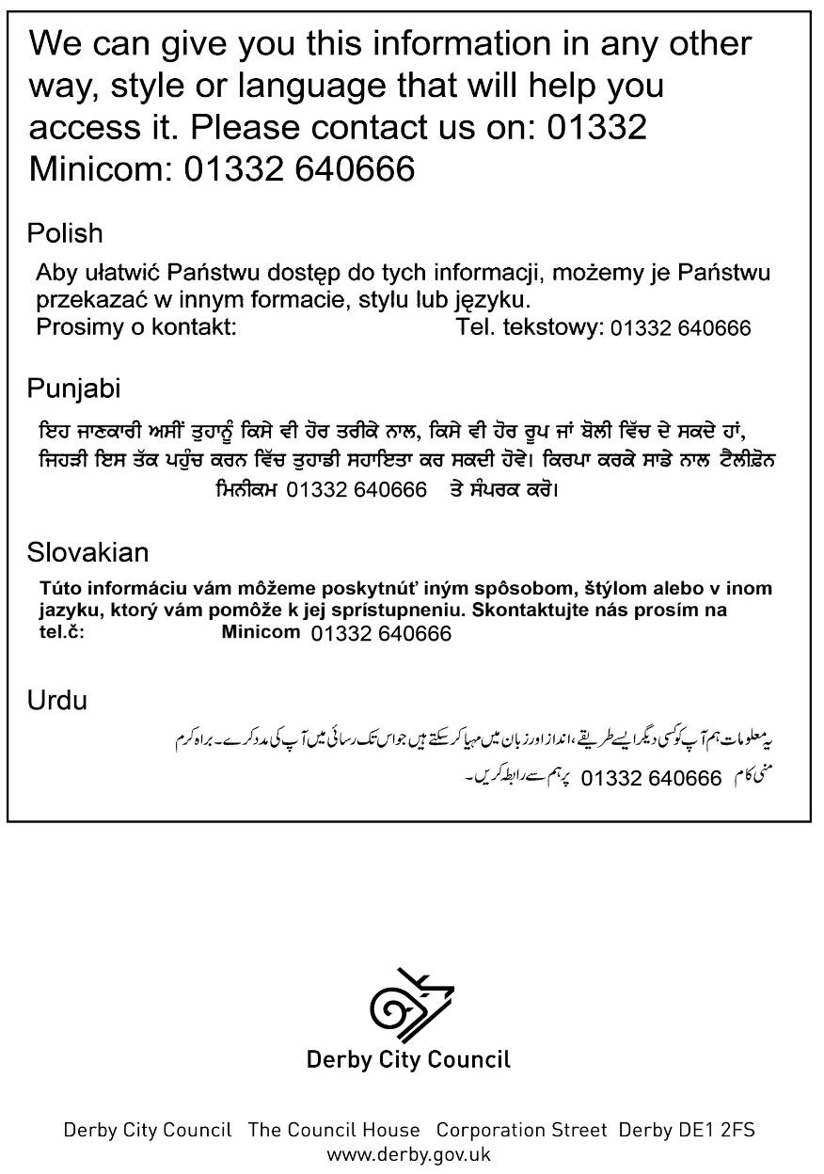
We’ve adapted our usual equality impact assessment form so you can use it for quick decisions needed concerning COVID 19. Remember it needs to be completed before that decision is made, but we hope it will just act as a reminder that we still need to ‘pay due regard to equality’ under our Public Sector Equality Duty as this is still very much in force. The Equality and Human Rights Commission are keeping an eye on examples of discrimination and collecting evidence so it’s important we still check for equality impact.

The Public Sector Equality Duty is part of the Equality Act 2010 and this Duty requires us as a public body to have ‘due regard’ to eliminating discrimination, harassment and victimisation and any other conduct that is prohibited by or under the Act. It requires us to advance equality of opportunity and foster good relations between people who share a ‘relevant protected characteristic’ and people who don’t. Protected characteristics are age, disability, gender identity, marriage and civil partnership, pregnancy and maternity, race, religion or belief, sex and sexual orientation.

Having ‘due regard’ means:
- removing or minimising disadvantages suffered by people due to their protected characteristics
- taking steps to meet the needs of people with certain protected characteristics where these are different from the needs of other people – this also involves taking account of disabled people’s barriers and may involve treating some people more favourably than others to achieve this
- encouraging people with certain protected characteristics to participate in public life or in other activities where the participation is disproportionately low.

We usually ask for teams to complete Equality impact assessments, but we realise this is not helpful for quick decisions to do with COVID 19 so you can complete them yourself, if you can’t get a team together. Please ask Ann Webster, our Lead on Equality and Diversity for help and advice if you’re not sure about something. You’ll need to pull together all the information you can about how your proposal affects different groups of people so you can check whether they will be negatively or positively affected. Then you’ll need to look at ways of lessening any negative effects or making the service more accessible. Against every negative impact you will need to complete the mitigation section to explain how you will lessen the impact and what action you will take.

When you have completed the assessment, get it signed by your Head of Service or Service Director and send it to our Lead on Equality and Diversity for checking and to publish on our website. It’s a public document so make it easy to understand and no jargon please.

Contact for help
Ann Webster – Lead on Equality and Diversity
ann.webster@derby.gov.uk Tel 01332 643722 Mobile 07812301144

