Derby Early Intervention and Integrated Safeguarding Services

Derby City Locality Services.

April 2015.

Introduction.
This booklet builds on the information contained within the Derby Early Help Offer Booklet by providing contact details of key locality services within all localities across the city. This will help practitioners and managers alike in partner agencies make speedier and more direct contact with staff in integrated locality teams, thereby helping to improve service provision for clients across the city.

Locality Integrated Services Delivery Arrangements.
Operational and administrative bases for Derby’s integrated locality teams cover the following locality wards.
Locality 1 & 5 Integrated teams: The Council House, Corporation Street, Derby, DE1 2FS
Derwent, Chaddesden, Spondon, Oakwood, Mackworth, Allestree and Darley.
Locality 2 Integrated teams: 2, Stanley Road, Alvaston, Derby, DE24 0EX.
Sinfin, Alvaston, Boulton, Chellaston.
Locality 3 /4 Integrated teams: Ashtree House, 218, Osmaston Road, Derby, DE23 8JX.
Blagreaves. Littleover, Mickleover, Normanton, Abbey, Arboretum.
This is outlined in the map of the city overleaf.

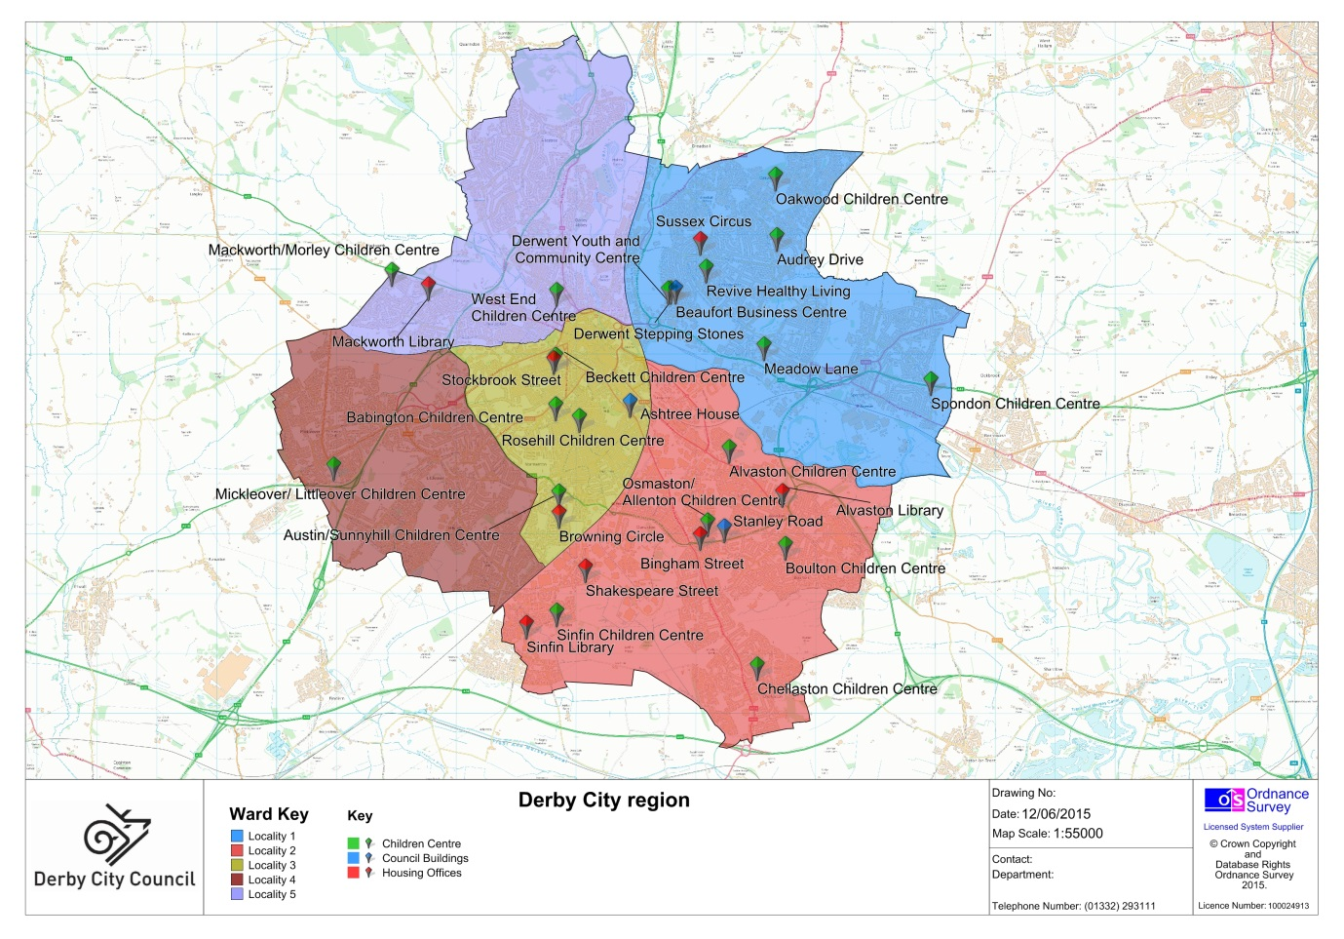

Integrated Services for Children and Young People in your Neighbourhood:
Locality 1.
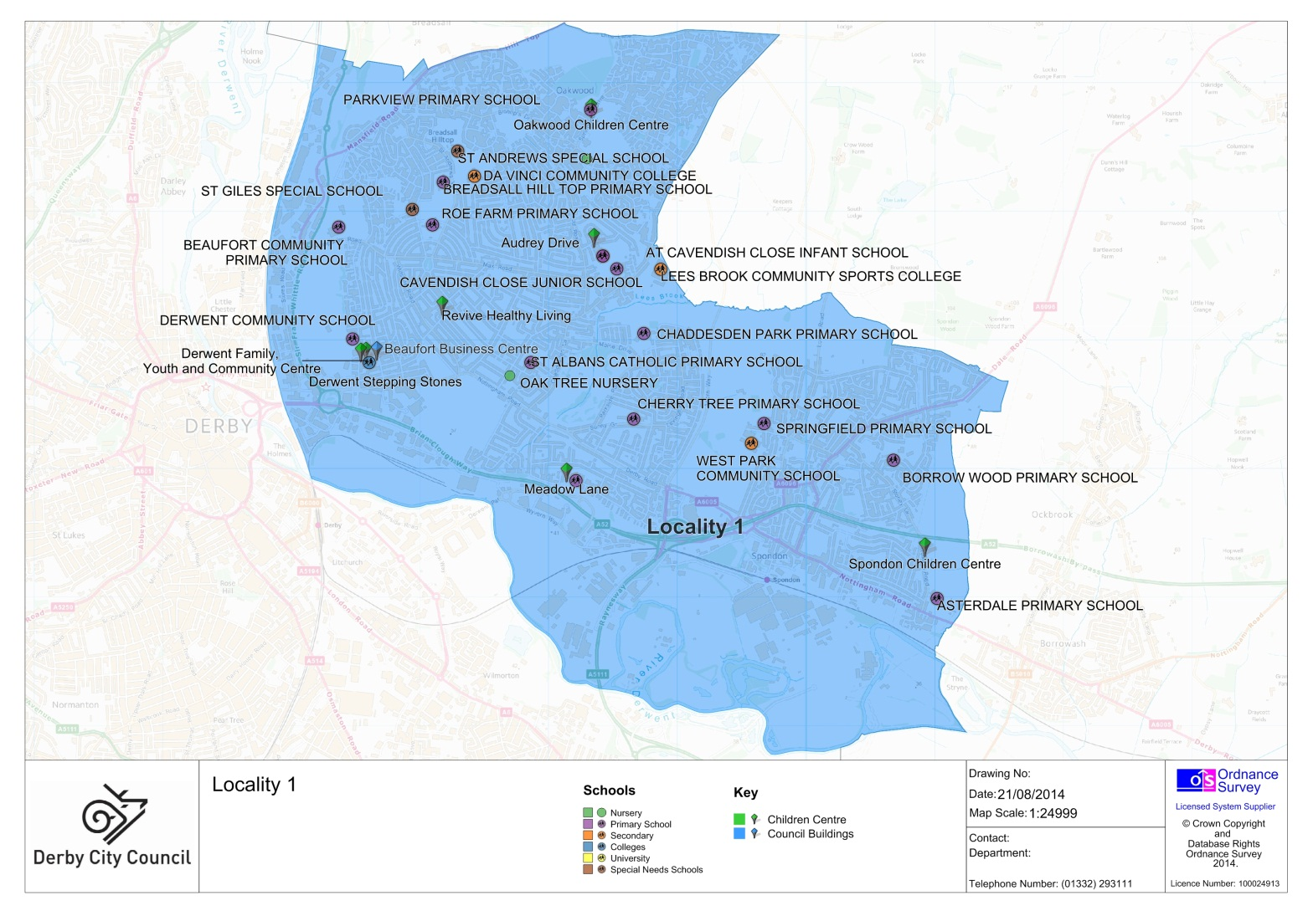
Head of Integrated Services is: Andrew Kaiser.
The Deputy Head of Safeguarding Services is: Tabitha Spencer
The Social Care Managers are: Theresa Woodall, Susie Hawkes, Liz Tanner and Tina Derrick.
The Children’s Centres Manager is: Sarah Cadle
The Under 11 MAT Team Manager is: Michelle Mignott
The Over 11 MAT Managers are: Tahir Abdullah and Sheila McGregor

Local Single Point of Access coordinator is: Sonia Gonzalez
The Local office phone number is: 01332 641334.

Child Protection
If you are concerned about the safety of a child, contact the First Contact Team on 01322 641172. For out of hours emergencies contact:
Safeguarding emergencies contact Care-line on 01332 786968
Royal Derbyshire Hospital on 01332 340131
Childline on Freephone 0800 11 11

Police
Derby North Policing Section is based at St Mary’s Wharf Police Station and local Police representatives are:
Inspector Paul Cannon
Safer Neighbourhood Youth Officer, PC 1713 Osbaldeston
Oakwood/Derwent and Chaddesden/Spondon Safer Neighbourhood Team’s
Sergeant 2602 Beeston
City Centre Safer Neighbourhood Team’s
Sergeant 3082 Clifton
Allestree/Darley and Mackworth Safer Neighbourhood Team’s
Sergeant 2553 Wilson
Contact 101 for all queries

Neighbourhoods.
North West Area Neighbourhood Manager: Jane Harrison, 01332 643050
Chaddesden: Adam Hullat, 01332 643059
Derwent: Jonathan Till, 01332 888725
Oakwood: Mandy Douglass/Yasmin Fazil, 01332 643061
Spondon: Mandy Douglass, 01332 643061

The Integrated Locality Teams include:
Youth Workers, Education Welfare Officers, Personal Advisors, Childrens Practitioners, Health Visitors, Runaways Workers, Family Visitors, Youth Crime Prevention Officers, Play Workers, Early Intervention Coordinators, Intensive Family Support Workers, Family Intervention Project Workers, Early Help Advisors,

Working alongside:
Education Psychologists, School Nurses, Health Visitors, Behaviour Support Officers, Drug and Alcohol Workers, Neighbourhood Managers, Housing Officers, School Improvement Partners.

Primary Schools:
Parkview Primary DE21 2RQ, 01332 835439
Breadsall Hilltop Junior DE21 4ET, 01332 341451
Breadsall Hilltop Infant and Nursery DE21 4ET, 01332 345131
Roe Farm Primary DE21 4HG, 01332 346310
Beaufort Primary DE21 6BT, 01332 347275
Cavendish Close Infant DE21 4LY, 01332 662239

Cavendish Close Junior DE21 4RJ, 01332 672338
Derwent Community DE21 6AH, 01332 346222
Chaddesden Park Junior DE21 6LF, 01332 662115
Chaddesden Park Infant DE21 6LF, 01332 673533
St Alban’s Catholic Primary DE21 6NU, 01332 673823
Cherry Tree Hill Primary DE21 6WL, 01332 673520
Springfield Primary DE217AB, 01332 673846
St Werburgh’s CE Primary DE21, 7LL 01332 673827
Borrow Wood Primary (lower) DE21 7QW, 01332 663937
(Upper) 662826
Meadow Farm Community Primary DE21 6TZ, 01332 662631
Asterdale Primary DE21 7PH, 01332 662323.

Special Schools:
St Andrew’s DE21 4EW, 01332 832746.
St Giles DE21 6BT, 01332 343039.

Secondary Schools:
Da Vinci DE21 4ET, 01332 831515
Lees Brook DE21 4QX, 01332 671723
West Park DE21 7BT, 01332 662337
Landau Forte DE21 2LF, 01332 204040.

GP Surgeries & Health Centres:
Chapel Street Medical Centre DE21 7RJ, 08444770920
Derwent Valley Medical Practice DE21 6AT, 01332 224588
Oakwood Surgery DE21 2DF, 01332 281220
Revive Healthy Living DE21 6ET, 01332 288700
The Park Medical Practice DE21 6LA, 08444773495.
Chaddesden Medical Centre, 465/7 Nottingham Road, Chaddesden, Derby, DE21 6NB.

Youth Centres:
Derwent, DE21 6BD, 01332 385321
Part time provision is available in Spondon, Chellaston and Chesapeake.

Locality 1 Derby Homes Manager: Pete Matthews
Housing Office: Sussex Circus, Chaddesden, Derby.

Integrated Services for Children and Young People in your Neighbourhood:

Locality 2.
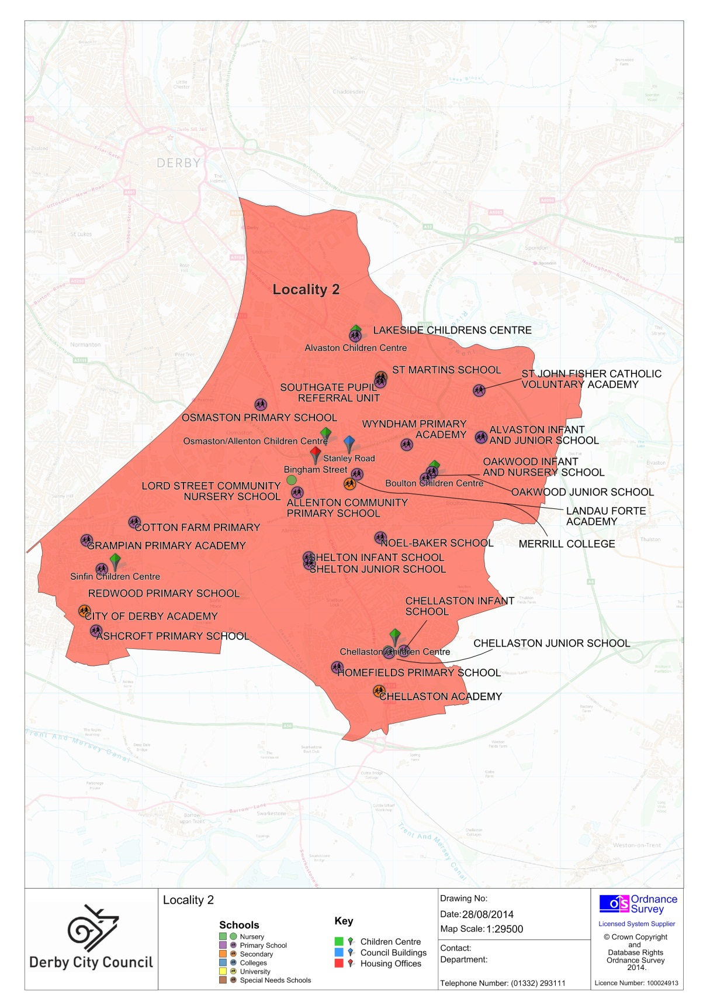

The Head of Integrated Services is: Fiona Colton

Deputy Head of Safeguarding Services is Bert Pollheimer
The Social Care Managers are: Michelle Jordan, Jotinder Atwal, Jade Bayliss and Laura Wickes
The Children’s Centres Manager is: Sarah Goodman

The Under 11 MAT team manager is: Lindsay Di Fusco

The Over 11 MAT Managers are Bev Evans (South) and Kelly Ormond (North)

The local Single Point of Access coordinator is: Irma Cerutti

The Local Office Number is 01332 641017

Child Protection
If you are concerned about the safety of a child, contact the First Contact Team on 01322 641172. For out of hours emergencies contact:
Safeguarding emergencies contact Care-line on 01332 786968
Royal Derbyshire Hospital on 01332 340131
Childline on Freephone 0800 11 11

Police.

Derby Cotton Lane (Derby East Section)

Local Police representatives are:

Sergeant for Alvaston and Boulton: Simon Hawley

Sergeant for Chellaston, Sinfin and Osmaston: Andy King

Safer Neighbourhood Youth Police Officer – Mike Maquire

Contact: 101.

The Integrated Locality Teams include:
Youth Workers, Education Welfare Officers, Personal Advisors, Childrens Practitioners, Health Visitors, Runaways Workers, Family Visitors, Youth Crime Prevention Officers, Play Workers, Early Intervention Coordinators, Intensive Family Support Workers, Family Intervention Project Workers, Early Help Advisors, Counsellor (Locality 2 only).

Working alongside:
Education Psychologists, School Nurses, Health Visitors, Behaviour Support Officers, Drug and Alcohol Workers, Neighbourhood Managers, Housing Officers, School Improvement Partners.

Childrens Centres.

Alvaston Children’s Centre, 875 London Road, Alvaston, Derby, DE24 8UY, 01332 757991
Boulton Children’s Centre, 47b Holbrook Road, Alvaston, Derby, DE24 0DD, 01332 574902
Chellaston Children’s Centre, Maple Drive, Chellaston, Derby, DE73 6PZ, 01332 701086
Osmaston/Allenton Children’s Centre, 60 Cockayne Street North, Allenton, Derby, DE24 8XB, 01332 715620
Sinfin Children’s Centre, 345 Sinfin Lane, Sinfin Moor, Derby, DE24 9SF, 01332 718787
Details for local nursery schools can be found by contacting:
Family Information Service
Visit:www.derby.gov.uk/0to19information
Email: childrensinformationservice@derby.gov.uk
Tel: 01332 716383

Primary Schools:

Lakeside Primary, DE24 8UZ, 01332 571485

Osmaston Primary, DE24 8FT, 01332 348356

St John Fisher Catholic Primary, DE24 0PA, 01332 572154

Alvaston Jnr Community, DE24 0PU, 01332 571321

Alvaston Infant & Nursery, DE24 0PU, 01332 571704

Wyndham Primary, DE24 0EP, 01332 571153

Oakwood Infant, DE24 0GZ, 01332 574192

Oakwood Junior, DE24 0DD, 01332 571231

Homefields Primary, DE73 5NY, 01332 691351

Allenton Community, DE24 9BB, 01332 701144

Shelton Infant, DE24 9EJ, 01332 700353

Shelton Junior, DE24 9EJ, 01332 701212

Cottons Farm Primary, DE24 9HG, 01332 771370

Grampian Primary, DE24 9LU, 01332 765546

Redwood Primary, DE24 9PG, 01332 767443

Ash Croft Primary, DE24 3HF, 01332 764160

Chellaston Infant, DE73 1TA, 01332 700298

Chellaston Junior, DE73 1RD, 01332 701460

Homefields Primary, DE73 1NY, 01332 691351.

Special Schools:

St Martin’s, DE24 OBR, 01332 571151.

Secondary Schools:

Merrill Academy, DE24 0AN, 01332 576777

Noel-Baker, DE24 0BR, 01332 572026

Chellaston Academy, DE73 5UB, 01332 702502

City of Derby Academy, DE24 3AR, 01332 270450.

Neighbourhood Manager:

Imke Goalby, 01332 643042

Neighbourhood Officers:

Alvaston, Angela Mapp, 07812301830

Boulton, Rebecca Hudson, 07812300153

Sinfin, Sharon Booth, 07812301329

Chellaston, Georgina Fowler, 07812300613

Housing Offices:

Bingham Street, Allenton, Derby, DE24 9BS

Alvaston Library, London Road, Alvaston, Derby, DE24 8QP

Sinfin Library, Sinfin District Centre, Derby DE24 3DS.

Shakespeare Street, Sinfin, Derby, DE24 9HE.

Youth Centres:

Sinfin, DE24 9PG, 01332 718787

Southgate, DE24 8TE, 01332 572412.

GP Surgeries & Health Centres:
Meadowfields Practice Allenton Surgery, DE24 8NH, 01332 861180
Meadowfields Practice Chellaston Surgery, DE73 6SW, 01332 700455
Chellaston Medical Centre, DE73 5BG, 01332 720077
Alvaston Medical Centre, DE24 0GE, 08444994770
Gould ADW Surgery, DE24 8OJ, 01332 784684
Haven Medical Centre, DE24 0RY, 01332 571677
Hollybrook Medical Centre, DE24 3DS, 01332 770909

Integrated Services for Children and Young People in your Neighbourhood:

Locality 3.

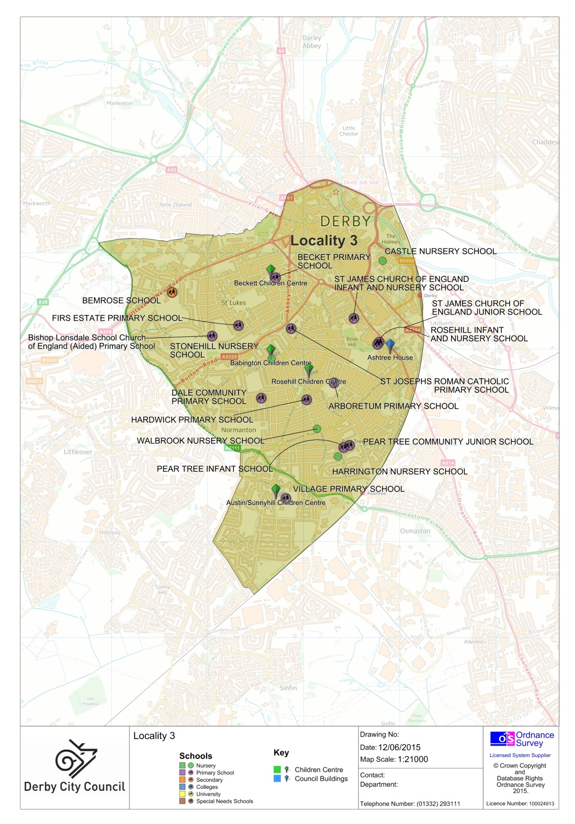

The Head of Integrated Services is: Donna Brooks

Deputy Head of Safeguarding Service is: Julie Maunder.

The Social Care Managers are: Carol Durand, Lisa Walker and Laura Garbutt.

The Children’s Centres Manager is: Hedia Aslam

The Under 11 MAT Manager is Jonathan Howie

The Over 11 MAT Managers are: Ali Lewsley and Jasvir Kaur Bahth

Your local Single Point of Access coordinator is: Chantelle Goodard

The Local Office Number is 01332 641172

Child Protection

If you are concerned about the safety of a child, contact the First Contact Team on 01322 641172. For out of hours emergencies contact:
Safeguarding emergencies contact Care-line on 01332 786968
Royal Derbyshire Hospital on 01332 340131
Childline on Freephone 0800 11 11

Police

Local Police representatives are:

Section Inspector Derby West D Division - Richard Keene, 1435

Abbey Ward - Sergeant Steve Todd, 443
Normanton/Arboretum - Sergeant Sally Dachlter, 2500
Mickleover/Blagreaves -Sergeant Julian Bonsall, 1647

Safer Neighbourhood Youth Police Officer - Michael Maguire 387

The Integrated Locality Teams include:
Youth Workers, Education Welfare Officers, Personal Advisors, Childrens Practitioners, Health Visitors, Runaways Workers, Family Visitors, Youth Crime Prevention Officers, Play Workers, Early Intervention Coordinators, Intensive Family Support Workers, Family Intervention Project Workers, Early Help Advisors,
Working alongside:
Education Psychologists, School Nurses, Health Visitors, Behaviour Support Officers, Drug and Alcohol Workers, Neighbourhood Managers, Housing Officers, School Improvement Partners.

Children’s Centres:
Austin/Sunnyhill, DE23 8DN, 01332 711340
Babington (Normanton), DE23 6TJ, 01332 344109
Rosehill, DE23 6WY, 01332 641315
Beckett, DE22 3WR, 01332 380134.

Primary Schools
Becket Primary, DE22 3QB, 01332 347595
Firs Estate Primary, DE22 3WA, 01332 346230
St Joseph’s Catholic, DE23 6SB, 01332 361660
St James’ CE Infant, DE23 8EG, 01332 363091
St James’ CE Junior, DE23 8FQ, 01332 340628
Rosehill Infant & Nursery, DE23 8FQ, 01332 347373
St Chads’ CE Infant/Nursery, DE23 6WR, 01332 345997
Arboretum Primary, DE23 8GP, 01332 291140

Hardwick Primary, DE23 6QP, 01332 272249
Dale Community Primary, DE23 6NN, 01332 760070
Pear Tree Junior, DE23 8PN, 01332 760610
Pear Tree Infant, DE23 8PN, 01332 767244
Village Primary, DE23 8DF, 01332 766492

Secondary Schools:
Bemrose, DE22 3HU, 01332 366711.

Neighbourhood Managers:
Abbey: Toni Leatherland 01332 716550
Arboretum: Imke Goalby 01332 715267
Normanton: Colin Avison 01332 711325

Housing Offices:
Browning Circle, Derby, DE23 8AR
Stockbrook Street, Derby, DE22 3WH.

Youth Centres:
Madeley Centre - Lead Worker - Muhammad Mahroof
Merlin Centre

GP Surgeries & Health Centres
Clarence Road Surgery, DE23 6LR, 01332 768912
Derby Family Medical Centre, DE23 6QQ, 01332 773243
Derby Open Access Centre, DE23 8RG, 01332 2929369
Lister House DE23 8RJ, 01332 271212
Normanton Medical Centre, DE23 8RH, 01332 765100
Peartree Medical Centre, DE23 8NQ, 01332 360692
Village Medical Centre, DE23 8AL, 01332 777070
Charnwood Surgery, DE1 1TH, 0844 4778585
Wellside Surgery, DE1 1TH, 01332 737777.

Integrated Services for Children and Young People in your Neighbourhood:

Locality 4

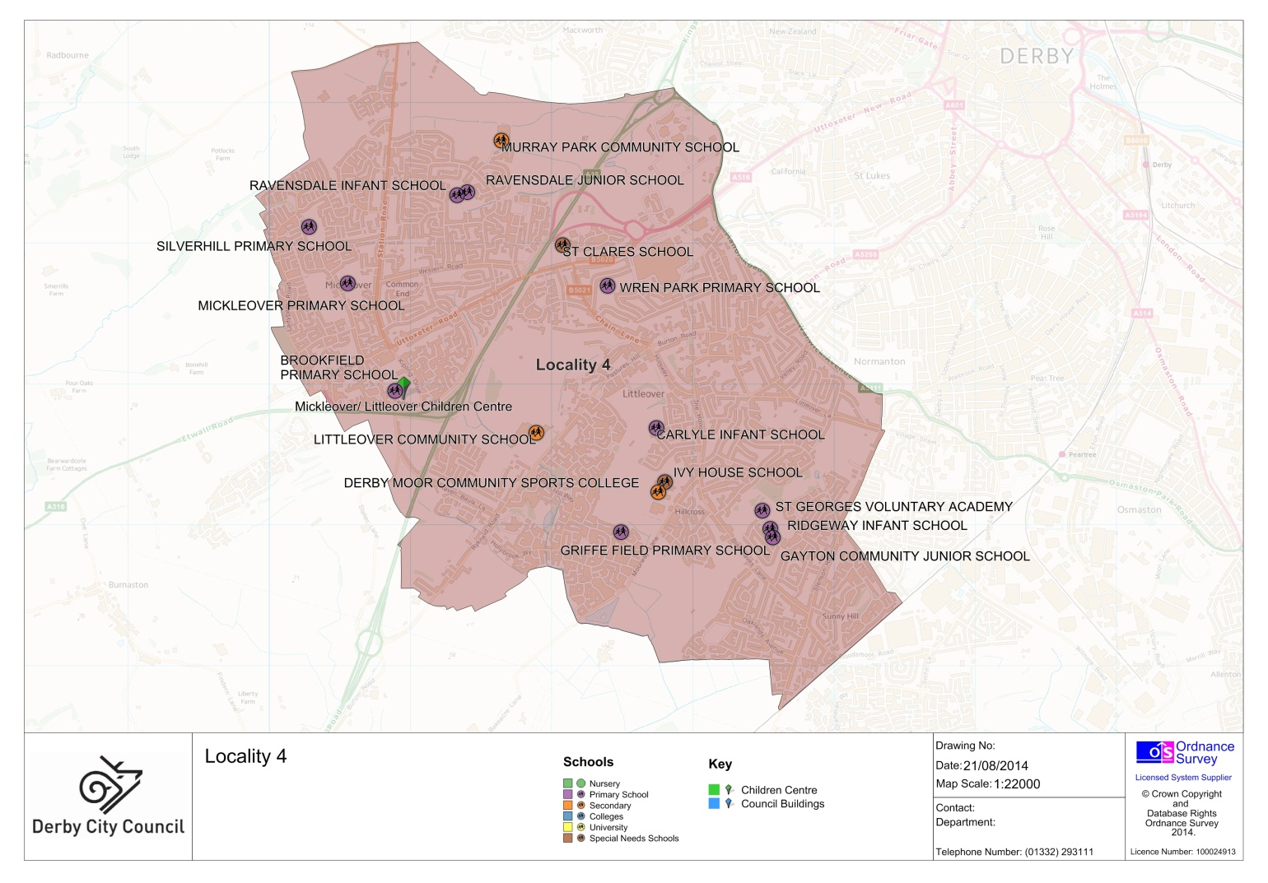

The Head of Integrated Services is: Donna Brooks.

Deputy Head of Safeguarding Service is: Julie Maunder.

The Social Care Managers are: Carol Durand, Lisa Walker and Laura Garbutt.

The Children’s Centres Manager is: Hedia Aslam.

The Under 11 MAT Manager is: Jonathan Howie.

The Over 11 MAT Managers are: Ali Lewsley and Jasvir Kaur Bahth

Your local Single Point of Access coordinator is: Chantelle Goodard

The Local Office Number is 01332 641172.

Child Protection

If you are concerned about the safety of a child, contact the First Contact Team on 01322 641172. For out of hours emergencies contact:
Safeguarding emergencies contact Care-line on 01332 786968
Royal Derbyshire Hospital on 01332 340131
Childline on Freephone 0800 11 11

Police

Local Police representatives are:

Section Inspector Derby West D Division: Richard Keene, 1435

Abbey ward: Sergeant Steve Todd, 443

Normanton/Arboretum: Sergeant Sally Dachlter, 2500

Mickleover/Blagreaves: Sergeant Julian Bonsall, 1647

Safer Neighbourhood Youth Police Office: Michael Maguire 387

The Integrated Locality Teams include:
Youth Workers, Education Welfare Officers, Personal Advisors, Childrens Practitioners, Health Visitors, Runaways Workers, Family Visitors, Youth Crime Prevention Officers, Play Workers, Early Intervention Coordinators, Intensive Family Support Workers, Family Intervention Project Workers, Early Help Advisors,

Working alongside:
Education Psychologists, School Nurses, Health Visitors, Behaviour Support Officers, Drug and Alcohol Workers, Neighbourhood Managers, Housing Officers, School Improvement Partners.

Children’s Centres.
Mickleover/ Littleover, DE3 9SA, 01332 518861.

Primary Schools.
Ravensdale Infant/Nursery, DE3 9EY, 01332 513862
Ravensdale Junior, DE3 9EY, 01332 512373
Silverhill Primary, DE3 0QE, 01332 511138
Mickleover Primary, DE3 0EY, 01332 514052
Wren Park Primary, DE3 9AY, 01332 512732
Brookfield Primary, DE3 0BW, 01332 516459
Carlyle Infant, DE23 3ES, 01332 760369
St Peter’s CE Junior, DE23 6FZ, 01332 767158
St George’s Catholic, DE23 1GG, 01332 76815
Ridgeway Infant, DE23 1GG, 01332 760770
Gayton Junior, DE23 1GA, 01332 760372
Griffefield Primary, DE23 3UQ, 01332 515718.

Special Schools.
Ivy House School, DE23 2FS, 01332 777920.
St Clare’s School, DE3 9AZ, 01332 511757

Secondary Schools.

Murray Park School, DE3 9LL, 01332 515921

Littleover School, DE23 4BZ, 01332 513219

Derby Moor School, DE23 2FS, 01332 772706.

Neighbourhood Managers:

Mickleover: Sarah Dosunmu 01332 711325

Littleover: Sarah Dosunmu 01332 711325

Blagreaves: Sharon Sewell 01332 711309.

Youth Centres.
Mickleover Nanda Savage lead worker.

GP Surgeries & Health Centres
Hollybrook Medical Centre, DE23 3TX, 01332 523300.
Mickleover Medical Centre, DE3 0HA, 01332 513283.
Mickleover Surgery, DE3 9BJ, 01332 519160.

Integrated Services for Children and Young People in your Neighbourhood:

Locality 5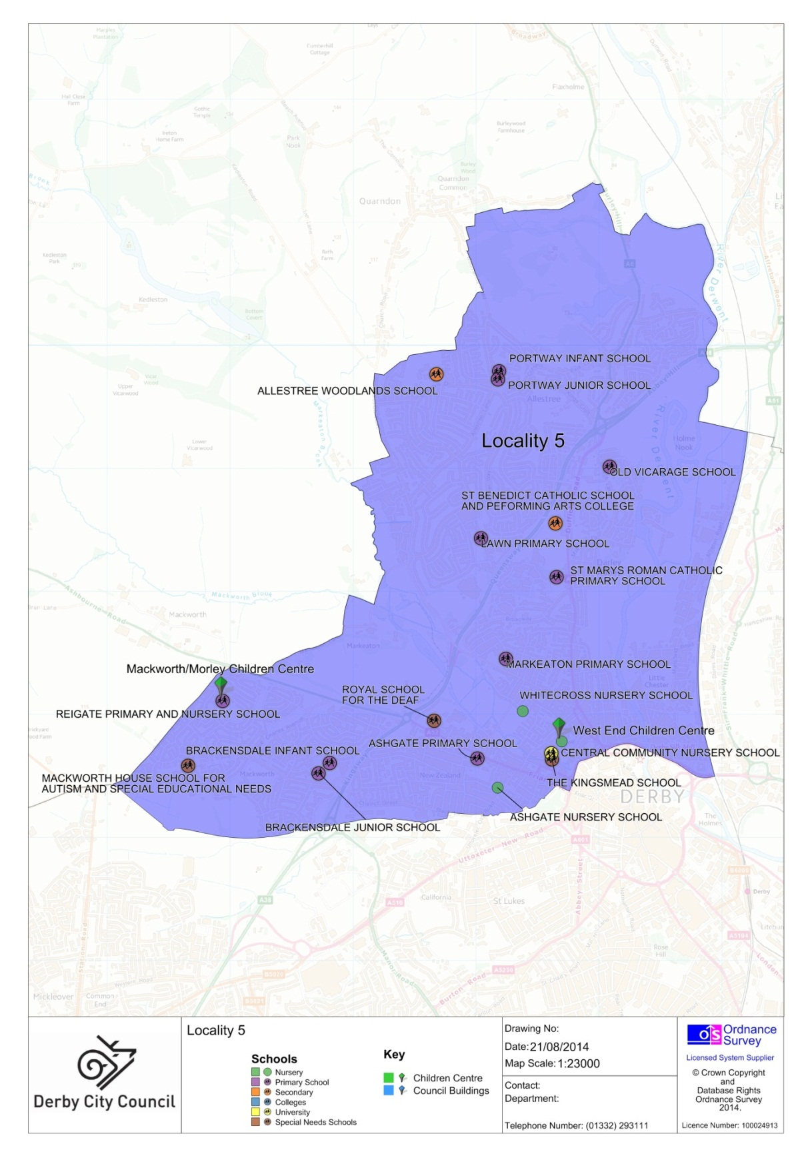

Head of Integrated Services is: Andrew Kaiser.
The Deputy Head of Safeguarding Services is: Tabitha Spencer
The Social Care Managers are: Theresa Woodall, Susie Hawkes, Liz Tanner and Tina Derrick
The Children’s Centres Manager is: Sarah Cadle
The Under 11 MAT Team Manager is: Michelle Mignott
The Over 11 MAT Managers are: Tahir Abdullah and Sheila McGregor
Local Single Point of Access coordinator is: Sonia Gonzalez
The Local office phone number is: 01332 641334.

Child Protection
If you are concerned about the safety of a child, contact the First Contact Team on 01322 641172. For out of hours emergencies contact:
Safeguarding emergencies contact Care-line on 01332 786968
Royal Derbyshire Hospital on 01332 340131
Childline on Freephone 0800 11 11

Police
Derby North Policing Section cover the west of the city and are based at St Mary’s Wharf Police Station, local Police representatives are:
Inspector Paul Cannon
Safer Neighbourhood Youth Officer, PC 1713 Osbaldeston
City Centre Safer Neighbourhood Team’s
Sergeant 3082 Clifton
Allestree/Darley and Mackworth Safer Neighbourhood Team’s
Sergeant 2553 Wilson - Contact 101 for all queries

Neighbourhoods.
North West Area Neighbourhood Manager: Jane Harrison, 01332 643050
Allestree: Jenny Lister, 01332 641874
Darley: To be confirmed.
Mackworth: Ray Gibson, 01332 643026
Mickleover: Jenny Lister/Zahida Hussain, 01332 641874

The Integrated Locality Teams include:
Youth Workers, Education Welfare Officers, Personal Advisors, Childrens Practitioners, Health Visitors, Runaways Workers, Family Visitors, Youth Crime Prevention Officers, Play Workers, Early Intervention Coordinators, Intensive Family Support Workers, Family Intervention Project Workers, Early Help Advisors,

Working alongside:
Education Psychologists, School Nurses, Health Visitors, Behaviour Support Officers, Drug and Alcohol Workers, Neighbourhood Managers, Housing Officers, School Improvement Partners.

Children’s Centres
Mackworth/Morley, DE22 4EQ, 01332 208175
West End, DE1 3LR, 01332 342647.

Primary Schools.
Portway Infant, DE22 2HE, 01332 550702
Portway Junior, DE22 2GL, 01332 550113

Walter Evans CE, DE22 1EF, 01332 557139
Lawn Primary, DE22 2QR, 01332 550178
St Mary’s Catholic, DE22 1AU, 01332 554831
Markeaton Primary, DE22 1HL, 01332 347374
Reigate Primary, DE22 4EQ, 01332 298969
Brackensdale Junior, DE22 4BS, 01332 341171
Brackensdale Infant, DE22 4BS, 01332 348314
Ashgate Primary, DE22 3FS, 01332 343928.

Special School.

Kingsmead School, DE1 3LB, 01332 715970.

Secondary Schools.

Woodlands, DE22 2LW, 01332 551921

Saint Benedict’s, DE22 1JD, 01332 557032.

Locality 5 Derby Homes Manager: Paula Solowij 01332 888645
Housing office: Brook Street, Derby.

Youth Centres.

Mackworth Youth Centre Lead Worker: Chris Morris.

GP Surgeries & Health Centres.
Brook Medical Centre, DE22 1FT, 01332 291991
Park Farm Medical Centre, DE22 2QN, 01332 559402
Park Lane Surgery, DE22 2DS, 01332 552461.

Integrated Disabled Children’s Service (IDCS) @ the Lighthouse.

The IDCS provides services for disabled children across the city; access to services is through an Early Help Assessment to the SPA.
Head of IDCS is: Suanne Lim (Interim) 01332 256950
Manager of the Fieldwork Team is: Harbax Saini 01332 256948
Manager of the nursery is: Vacant
Manager of the Community Support & Home Care Team is: Theresa Lane 01332 256972
Manager of the therapy team is Kathryn Hughes: 01332 256960
Manager of the residential short break centre is Libby Gaskin: 01332 256994
Acting Unit Manager of Shine is: Gemma Bullock 01332 518606
IDCS Single Point of Access (SPA) coordinator is Laura Price: 01332 256990.
The Integrated Disabled Children's Service (IDCS) is based at the Light House. The Light House is a purpose built environment for disabled children and the staff who work with them. The IDCS is jointly funded by Derby City Council and Southern Derbyshire Clinical Commissioning Group.
Services available from the Light House include:

• Community & Home Support
• Residential Short Breaks
• Social Workers
• Children's Practitioners
• Occupational Therapists
• Physiotherapists
• Community Learning Disability Nurse
• Specialist Nursery
• Community Short Breaks
• Youth Service
• Speech and Language Therapist
• Direct Payments
Shine, a specialist residential home for children who have a speech and language difficulty and autism.

For more info: www.derby.gov.uk/thelighthouse.

Youth ‘one stop shop’ (IYSS) the Space @ Connexions.

Benefits, training and employment advice, volunteering, Sexual health, CAMHS, Pregnancy and Chlamydia testing.

Centre manager – Jonie Centro: 01332 643900

Aspire services for young people leaving care: Service Manager - Bev Fearn: 01332 717005

Sexual Health session times:

Tuesday 5 - 7.15pm Appointments only
Thursday 3.30 - 6pm Drop-in and appointment
Saturday 12.30am – 3.30pm Drop-in

Counselling session times:

Monday 9.30 – 17.00
Tuesday 9.30 – 17.00
Wednesday 9.30 – 11.00
Thursday 9.30 – 17.00
Friday 9.30 – 16.30.

