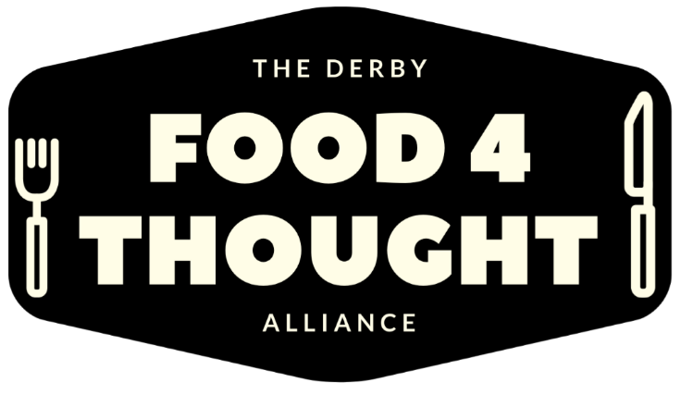
School Uniform Drop, Swap & pick up request form
In partnership with Derbion and local projects, we are offering support of school uniforms (where available) to help alleviate the stress on families in our community who are financially struggling to meet the household’s commitments. If you feel you are in need of this support, please can you complete all parts of this form. We will allocate (where possible) a uniform pack per child this will include: 1 jumper, 2 polo shirts/shirts, 1 pair of trousers/skirt. Additional items may be available upon request. This may include PE Kits.
Once this form is completed, please email to info@df4ta.onmicrosoft.com if you are not able to email request, please call the Community Hub on 01332 346266 stating that you are in need of school uniform support and you will be transferred to the appropriate team member.
NAME:
ADDRESS:
POSTCODE:

PHONE NUMBER:
Number of children to be supported:

Childs clothing size for each child
3-4 4-5 5-6 6-7 7-8 8-9 9-10 10-11
11-12 12-13 13-14 14-15 15-16

PE Kit : Please state for which aged child & required sizes

Notes: If you require specific items for your school or only require a couple of items not whole pack, please state here - for example - shirts or polo shirts,
colour of jumper,
colour of trousers,
skirt

If you are referring on behalf of a family you are supporting, please give your name, organisation and contact details – phone & email and confirm family has given consent for referral.

Derby Food 4 Thought Alliance is a registered charity number 1198665.
Registered office: 30 Charnwood St, Derby, DE1 2GU https://www.derbyfood4thoughtalliance.org.uk .

