Doctor’s Certificate Account Number
(to be filled in and returned by a registered medical practitioner ONLY)

Via Email: council.tax@derby.gov.uk

Postal address:
The Council House
Corporation Street
DERBY
DE1 2XG

Before completing this certificate, please read the guidance notes overleaf.

This certificate is for use in deciding whether the person named is severely mentally impaired for Council Tax purposes and should be completed by a registered medical practitioner.

Full name of the severely mentally impaired person

Address

I certify that in my medical opinion the person named above

is not

is

suffering from severe mental impairment for the purpose of the Local Government Finance Act 1992

Day Month Year
If yes, please provide the date in your medical opinion the person became SMI.

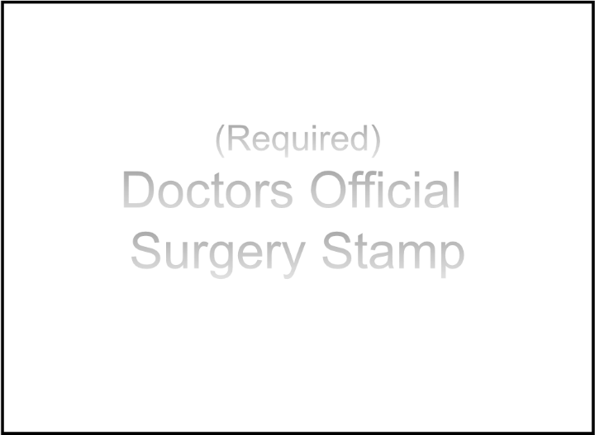
Doctor’s Signature:

Doctor's full name in block capitals:

Surgery/hospital full address including postcode:

FOR USE BY A REGISTERED MEDICAL PRACTITIONER
(Please ensure that these notes are passed to your doctor).

COUNCIL TAX DISCOUNT FOR PEOPLE WITH SEVERE MENTAL IMPAIRMENT

The Department of Health letter PL/CO (93) 1 issued to all general medical practitioners in March 1993 states: “Doctors should note that the decisions to whether a person is severely mentally impaired is not consequent on any specific diagnosis. A person is severely mentally impaired if he has a severe impairment of intelligence and social functioning, however caused, which appears to be permanent. A decision about the presence of severe mental impairment will, in all cases, depend on the doctor’s clinical judgement as to whether the applicant meets these criteria”

“If a doctor is uncertain whether an applicant’s intelligence and social functioning are such as to constitute severe mental impairment, he may wish to seek information and advice from appropriate medical colleagues or from colleagues in other professions, or from carers, who may be able to help with
information based on their knowledge of the applicant. If, after such consultation, a doctor is still uncertain whether or not an applicant is severely mentally impaired, he or she should not sign the certificate."

CHARGING FOR THE CERTIFICATE
The General Medical Services Committee of the BMA has agreed that for the purpose of the Act medical certificates should be issued without charge to the applicant or his representative, it is intended that regulations will be amended to add the certificate to Schedule 9 of the NHS (General Medical Services) Regulations 1992 with effect from 1 April 1993.
https://www.bma.org.uk/advice/employment/fees/certificates-no-charge

DEFINITION OF SEVERE MENTAL IMPAIRMENT AND CONDITIONS FOR DISCOUNT

The definition of severe mental impairment under the Local Government Finance Act 1992 is that a person is severely mentally impaired “if he has a severe impairment of intelligence and social functioning (however caused) which appears to be permanent”.

This definition applies only for the purposes of the Local Government Finance Act 1992. The definition is not the same as the definition of “severe mental impairment” in the Mental Health Act 1983.

In making a judgement on whether someone is severely mentally impaired it may be helpful for doctors to know the reason for discount from the Council Tax. The aim of the Council Tax is to give taxpayers a
direct stake in the spending decisions of local authorities. Clearly this kind of accountability is much less successful in the case of someone who is severely mentally impaired to the extent that he or she does not have an understanding of local issues.

Doctors may wish to be aware that being classified as severely mentally impaired for the purpose of the Local Government Finance Act 1992 does not affect the right to vote or to be included in the electoral register which is compiled separately and with different qualifying criteria.

This certificate is for use only in applying for discount/exemption from Council Tax

