

Markeaton Park Craft Village
UNIT B - TO LET

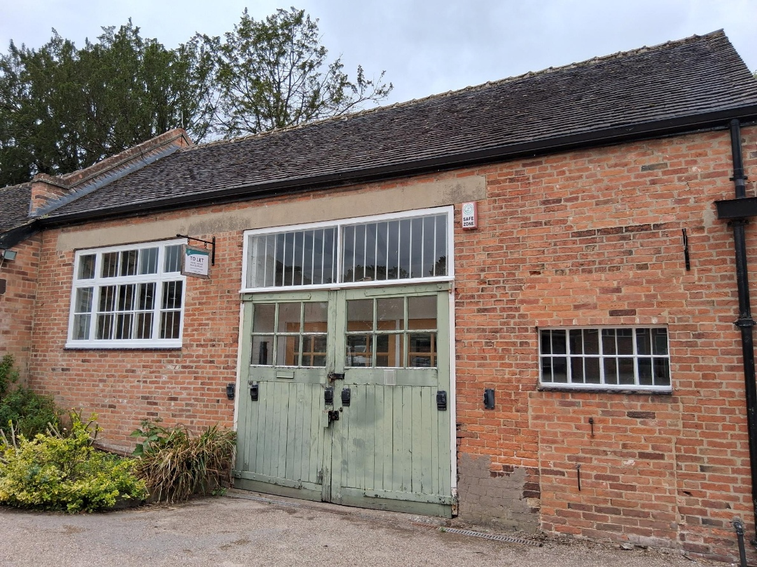

- Located as part of a group of craft-based businesses in the popular Markeaton Park.

- Unit B 525 sqft
- Rent £5,500 p/a

- Expressions of interest sought

- For further information contact James Tilford at james.tilford@derby.gov.uk

Or on 07741091339

General  The units on offer form part of an established group of craft-based businesses, occupying a central position in Markeaton Park, Derby.  Location  Markeaton Park Craft Village, Markeaton Park, Derby. DE22 3BG  Located within Derby's premier and most popular park within a set of 18th century historic outbuildings that were attached to the now demolished Markeaton Hall.  The Craft Village comprises a mix of established craft businesses surrounding a courtyard. The Craft Village has undergone some restoration and refurbishment work including the transformation of the adjacent Orangery Café funded as part of the Markeaton Park Restoration Project.  Accommodation  The approximate internal area of the units and the Council’s guide rents (per year) are as follows:  Units have electricity, mains water and a BT telephone line.  Terms  The premises are offered by way of a new full  repairing lease for a term to be agreed but suggested at between two and five years. Draft heads of terms for this lease are enclosed.  No service charge applies to these premises. | Business Rates  The rateable values are as follows: nil via small business rates relief  Small business rates relief may apply. For more information on eligibility see https://www.gov.uk/apply-for-business-rate-relief/small-business-rate-relief  EPC  A copy of the EPC is available upon request  Use  To be agreed.  VAT  At the time of preparing these details VAT does not apply to the rent.  Landlord’s Costs  The landlord is Derby City Council. The incoming tenant will pay the landlord’s legal and surveyors fees of £1000 in total.  Applications to rent the Craft Village premises will be evaluated in accordance with the criteria set out in this document. Derby City Council will assess offers as they are submitted.  Viewing and Further Information  Viewings of units will be conducted by appointment  To arrange a viewing or to request further information please contact James Tilford at  James.tilford@derby.gov.uk or on  07741091339  Please read the attached guidance to applicants including Annex 1, the draft Heads of Terms before completing the application form.
  Unit | Area | Guide Rent
  Unit B | 525 sqft | £5,500 p/a

MARKEATON PARK CRAFT VILLAGE

GUIDANCE TO APPLICANTS TO LEASE UNITS

- Introduction

Markeaton Park is Derby’s premier public park and is estimated to attract one million visitors per year from the local area and further afield to a range of attractions.

Markeaton Park including the Markeaton Park Craft Village (‘the Craft Village’) has undergone a £1.3 Million programme of improvements aimed to restore the historic 18th century park and features and to transform the quality of the visitor experience.

These works have resulted in significant improvements to the Craft Village.

The purpose of this document is to provide information to those interested in renting premises at the Craft Village. The document covers the following:-

- The details of the premises available to suitable individuals, companies and organisations engage in craft-based activities.
- The proposed terms of a tenancy.
- The Council’s attitude towards a pure or majority retail use.
- How the Council will analyse applications and select new tenants so that its objectives are achieved.
2 The premises available to let at the Craft Village

The table below provides a list of the units available:-

Unit ref. | Area (sq.ft.) | Guide annual rent (£)  (see notes) | Further details
B | 525 | 5,500 | Single opening door, level access. Fitted kitchen to rear of unit. Electricity sockets and lighting. No fitted heating

Note: - Our guide rent represents the Council’s target rent for the unit based on external advice on the demand for similar units. It is however down to each applicant to determine what rent it can afford to pay and what they need to offer in order to secure the property in open competition. The council will be flexible in considering rental offers.

3 The proposed terms of the Council’s tenancies at the Craft Village
We have attached our proposed ‘Heads of Terms’ to this document (see Annex 1) which applicants are advised to read very carefully so that they ensure that the costs of complying with the proposed lease obligations are reflected in their financial estimates.

Particular attention should be paid to the existence of ‘stay open’ provisions that require tenants to be open to the public at core times for the purchasing of goods and/or the viewing of crafts. Applicants should note that the existing tenants will shortly be entering into new leases that include provisions that require them to be bound by these opening times.

The Heads of Terms document is intended to form the basis of the City Council’s lease that will be prepared in due course.

4 The Council’s attitude towards a pure or majority retail use.
The Council would prefer to retain and strengthen the presence of craft-based activities at the Craft Village in order to ensure that it develops a reputation for providing a different offering from those provided in similar locations in the area. Examples of such businesses include:

- A craft or artisan business that requires a workshop with a retail outlet for the sale of goods direct to the public (e.g. a manufacturer of jewellery, an artist’s studio or a sculptor’s workshop).

- A specialist food outlet that does not compete with the Orangery Café, or other occupiers of the Craft Village.
However, there may be instances where the City Council might look favourably on a pure retail use – for example the Council would be keen on a retail gallery outlet that showcases and sells the art and craft that is predominately made by artists and crafts people from Derby and the surrounding area.

Applicants who may be considering such pure retail uses should note that the planning consent for the Craft Village is for B1 Light Industrial which does permit retail as ancillary to the main use as a workshop, but that the use of premises solely for retailing goods would require the submission of a planning application. Derby City Council Community Leisure and Estate sections would be prepared to work with a business that fulfilled all other criteria in securing the necessary planning approval, but the outcome of any application is a matter for Derby City Council as Planning Authority.

5 How the City Council will consider applications and select new tenants

The City Council welcome applications from individuals, companies and organisations that are involved in a craft-based activity and can demonstrate that it would contribute to the Council’s objectives with respect to:
- Adding to the overall attractiveness of both the Park and Craft Village throughout the year by complementing the offerings that the existing Craft Village tenants currently provide.
- Demonstrating that the activity will remain viable throughout the year and in doing so ensure that the Craft Village remains fully let.
All applicants should pay particular attention to the goods and services offered by each of the existing occupiers to ensure that their proposals are complementary and not competing in nature.

As the Council is seeking a broad range of businesses the Council will use the assessment process as a means to achieving this balance. This will involve a degree of assessment between submitted goods and services to ensure the selected uses are complementary and do not compete with each other.

Applications will be considered in accordance with the following criteria:-

- Proposed use – extent to which the proposed use complements the offerings provided by the existing occupiers and adds to the attractiveness of the park to visitors.

- Viability – demonstration that the proposed activity is viable and that the applicant has properly taken into account the implications of the draft Council’s Heads of Terms.

- Rent – the level of rent offered.

6 Summary

Applicants should now read Annex 1 Draft Heads of Terms for New Lease and then contact James Tilford at James.tilford@derby.gov.uk or on 07741091339

Annex 1
Markeaton Craft Village, Markeaton Park, Derby DE22 3BG
Draft Heads of Terms for New Lease
Subject to Contract
Address | Unit B
Landlord | Derby City Council, Corporation Street, Derby
Tenant | tbc
Annual Rent | £5,500 p/a
Landlord’s initial Works | None
Tenant’s Initial Works | The tenant is obliged to procure at his own expense a hanging sign, to DCC’s specification, and to arrange for the name of the tenant’s trade name to be written on the sign. The actual lettering to be subject to DCC’s approval. The sign is to be erected within two months of the start of the lease.
Lease length & start date | To be discussed – between two and five years.
Breaks | Landlord's and Tenant's right to break the lease upon 6 months' notice at any time.
Rights Granted to the tenant: | Rights listed below:
Parking | The right to park one car or small van in the car park at village entrance
Use of staff toilet | Use of dedicated staff toilet
Deliveries | Deliveries and loading/unloading by businesses and third parties to those businesses will take place on weekdays only between the hours of 8.00am and 11.00 am and from 4.00 pm to 6.30pm only.  The tenant shall not permit or encourage the public to access or use the courtyard for their personal vehicles for the purposes of collection or delivery of goods or for dropping off or collection of passengers at any time.  The Courtyard will be used for a range of events and activities. The tenant is not permitted to create a hazard or carry out any activity that prevents the safe use of this space.
Signage | The right to have a sign as referred to above under ‘Tenant’s initial works’.  The right to place an ‘A’ board in a location and to a design approved by DCC.  No other signs or advertisements to be placed on or adjacent to the buildings, or outside of the Courtyard.
Storage/collection of waste | The tenant is responsible for the removal of all waste from the premises. Waste and rubbish is not to be stored outside of the premises in the courtyard, car park or any other part of Markeaton Park. The tenant is to comply with Derby City Council’s Duty of Care (which is amended from time to time) relating to the disposal of waste. A copy of this can be found on DCC's website.
1954 Act protection | No. The lease is to be contracted out of the Landlord and Tenant Act 1954.
Rent Reviews | To be discussed.
Assignment & Subletting | Prohibited
Tenant’s Repairing obligations | The tenant is responsible for the maintenance and repair of the premises, with the exception of the roof and structure (which DCC will be obliged to repair and maintain).  The tenant’s obligations will include internal and external decoration, the maintenance of the guttering and the glazing.  The unit is to be kept clean and tidy at all times, and the tenant is to be responsible for the removal of litter from the area immediately in front of the premises.
Alterations | Structural alterations are not permitted.  Any external alterations are not permitted.  Internal non-structural alterations are permitted, subject to the landlord’s consent.  The tenant may require planning approval and/or listed building consent for any alterations to the unit and will be responsible for obtaining all necessary consents before carrying out any work. The tenant shall provide written evidence to the Landlord that the appropriate consent has been obtained or is not required.
Stay-Open Provisions | Units shall be open to the public for the purposes of purchasing goods or viewing craft activities during all the following times:  Bank Holidays  10.00am to 5.00pm with the exception of Christmas Day, Boxing Day and News Years Day.  April to September inclusive  Weekdays not in school holidays: Tuesday to Friday 11.00am to 4.30pm  Weekdays in school holidays: Monday to Friday 10.00am to 5.00pm  Weekends: 10.00am to 5.00pm  October to March inclusive  Weekdays not in school holidays: Tues to Friday 11.00am to 3.00pm  Weekdays in school holidays: Monday to Friday 10.30am to 3.30pm  Weekends 10.30pm to 3.30pm  School holiday dates shall be those that apply within Derby and will vary each year.  Businesses may at their own choice open outside of the above hours.  The tenant will be permitted to close the premises during opening hours as follows:  - For a holiday or holidays for no longer than two weeks outside the period between Easter and 30 September. The tenant shall notify the landlord at least two weeks in advance and ensure closing dates are properly advertised to the public and customers.  - On an occasional basis for the purpose of carrying out their business off site should their work necessitate this, for example for the fitting or installing of goods made by the tenant.  - For one week between October and March (excluding Easter) for the purposes of cleaning, decorating, refitting or other improvement to the unit where agreed in advance with the landlord.  If the business is closed due to illness or other unforeseen circumstances the tenant should notify the landlord as soon as possible.
Security and Management of the Craft Village | To comply with the rules and regulations relating to management and security as issued in writing, and updated from time to time.
Permitted Use | To be discussed.
Insurance | DCC to insure the premises and the cost of the premium is to be recovered from the tenants, as an annual payment.  For the avoidance of doubt the landlord will not insure the tenant's contents of the premises.  The tenant is to carry adequate public liability insurance and must be able to provide evidence of this if requested to do so by the landlord, at any time.
Rates and other taxes | To be paid by the tenant.
Electricity & Water | To be paid by the tenant.
Health & safety issues | The tenant is to be responsible for ensuring that the premises are safe for use by the tenant, his employees and visitors including members of the public. This will include regular checks to the water, electrics and fire safety.  The landlord may levy an annual charge for checking that the tenant has complied with his obligations in this regard.
Timing | New lease to be completed as soon as possible.
Landlord’s solicitors | tbc

Detailed information on the wide range of attractions located in the park including the Mundy Play centre can be found at http://www.derby.gov.uk/environment-and-planning/parks-and-open-spaces/markeaton-park/mundy-play-centre/
For further information on the Markeaton Park Restoration Project go to http://www.derby.gov.uk/environment-and-planning/parks-and-open-spaces/markeaton-park/markeaton-park-restoration-project/

