Derby City Centre Mural Artwork Commission Opportunity

Information and Guidance Notes

Background and Context
A positive experience when visiting a city is essential to improve reputation, increase footfall and encourage repeat visits. Commissioned artworks can create eye-catching interventions within the public realm, which surprise and engage, connecting people and place, whilst changing the look and feel of the city centre.

In 2025 two transformational projects will open in Derby City Centre. These being the new 3,500 capacity Becketwell Arena and the refurbished Derby Market Hall. Alongside these projects a range of public realm works are underway to enhance the look and feel of the city centre and improve the visitor experience. Within these public realm works we are looking to commission building artworks in four prominent locations. These have the aim of building pride in place and engagement in local culture and community.

We are seeking proposals from artists experienced in delivering large scale mural artworks within the public realm. Thematic guidance is provided below to help inform your proposals.

Thematic Guidance
The information below is for guidance only, it is not essential that proposals reflect these themes. We are interested in seeing creative responses to the space and context of the artwork location. Appendix 1 contains further information relating to thematic considerations for specific locations.
- A new city narrative is emerging of Derby the Pioneering City. “Derby has a long history of firsts powered by trailblazers and can-doers. From global engineering technologies, to inventing manufacturing processes, from transformative arts to groundbreaking healthcare, Derby has been quietly, yet consistently, changing the world for hundreds of years. The people of the City have never stopped dreaming and making, they continue to forge a new path and break new ground so others can follow. Today we see a vibrant collective of Derby pioneers taking the City forward in increasingly sustainable, innovative and creative ways.” We would be interested to receive proposals that reflect this pioneering spirit, portraying the people and movements and innovations of Derby past and present.
- Derby has a number of award-winning green spaces and the River Derwent flows through the centre of the city. Connection with nature is recognised for supporting wellbeing and positive mental health. We would be interested to receive proposals that bring flora, fauna and wildlife into the city centre.
- Ensuring diversity is visible and celebrated builds pride in a city and ensures people feel included and welcomed. We would be interested to receive proposals that will help the city centre to reflect the cultural identity of our communities.

How to Apply to the Derby City Centre Mural Artwork Commission Opportunity

Eligibility
It is expected that applicants will have experience of delivering commissions of similar scale within public realm locations.

Whilst our preference is for Derby based artists we recognise the specialist nature of the commissions. We will therefore consider proposals from artists based further afield. We are however keen for the commissions to develop experience of local artists, therefore the option to recruit any assistant roles locally should be considered.

Key Dates
- Deadline for submission of proposals is 10am on 13 January 2025
- We aim to complete assessments and issue decision letters by 27 January 2025
- Project delivery must be completed by 31 March 2025.

Completing the application form
Please answer all questions in the application form, providing relevant information to allow us to clearly understand and assess your proposal. You can submit proposals for more than one location, these should be done as separate applications.

Supporting Information
Your proposal should include a visualisation of your design showing it in the context of the building. You should explain the ideas behind your design and where appropriate, how it links to the suggested themes. We will accept preliminary or concept designs at application stage, with the understanding these would be worked up to final designs if selected.

You should also provide examples of your previous work relevant to this commission as a PDF (maximum 4 sides of A4), alongside links to website or Instagram account.

Budget breakdown
Please provide a breakdown of all costs associated with the project including development of final designs, materials, access requirements for the installation and any other appropriate costs.

The following maximum budget allocations have been made;
- BT Building – due to size and complex nature of the site, proposals are sought with a value up to £14k
- East Street Bridge – proposals are sought with a value up to £8k
- Tiger Bar – proposals are sought with a value up to £8k
- Nightingale Quarter – proposals are sought with a value up to £5k

Assessment of proposals will consider whether the budget is realistic and appropriate. You should therefore make a clear and concise case to justify the level of funding requested.

Submitting your application
Once you have completed your application please sign the declaration and collate all relevant supporting information. These should then be submitted to mike.brown@derby.gov.uk

What happens after you have submitted your application?
On receipt of an application, we will undertake an initial eligibility check to ensure the application is fully complete. If your application is incomplete, we will notify you of any outstanding information required. You will be given a set time to return this information. Failure to provide this within the given time may mean your application does not progress to assessment.

We will use the responses you provide to the Information Questions and Finance Questions to assess whether there is a genuine need for the level of funding requested and the suitability of the artwork for a public realm location. We will also consider strength of the ideas behind your proposal and previous experience.

If selected, you will be expected to undertake a site visit and complete final designs for approval by the selection panel. You will also be expected to provide a health and safety risk assessment, method statement, evidence of appropriate public liability insurance, and licenses to operate access equipment (if required).

The Council reserves the right not to progress with the mural artwork commissions.

What if my application is not approved?
We anticipate a high demand for the funding so it is unlikely we will be able to fund all applications. There is no right to appeal, and the council's decision is final. We will provide details of why your application was rejected or funded at a lower level than requested within our decision letter.

Further Information
If you have any questions relating to the fund or your application, or would like higher resolution images of the mural locations, please contact mike.brown@derby.gov.uk

Is the grant subject to tax?
Grant income received by a business is taxable. Therefore, funding paid under this scheme will be subject to tax. Only businesses which make an overall profit once grant income is included will be subject to tax.

Appendix 1: Property Locations

East Street Bridge, East Street, Derby
A prominent location spanning East Street, a pedestrianised area with mixed use retail and two entrances to the Derbion Shopping Centre. East Street is a key route linking Bus Station, Derbion Shopping Centre and Becketwell regeneration area. The commission is for both sides of the bridge.

The bridge dimensions are 12.5m wide (across the street) by 2.2m high. The underside of the bridge is 6m above the pavement. This is a high footfall area, access and public safety will be key considerations within delivering your commission. There are currently vinyl banners attached to the bridge which will be removed. The bridge surface is concrete.

View towards Albion Street and Bus Station
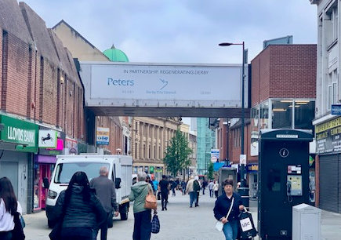

View towards St Peter’s Street
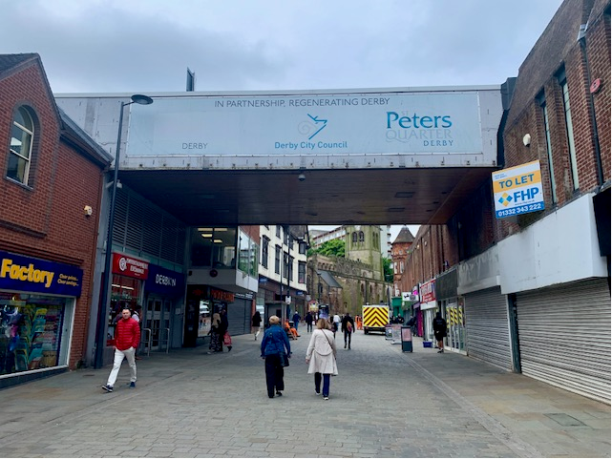
BT Building
This prominent location is within the Becketwell regeneration site. It is adjacent to the 3,500 capacity Becketwell Live performance venue (opening 2025) and overlooks a new urban square green space. The opposite side of the square has the Condor residential scheme.

The area for the mural is indicated by the red square below with priority being the brick areas. This is 17m wide by 13.3m high. The windows within the brick areas can be boarded over to provide a cleaner canvas for the artwork. Designs do not need to cover the entire surface area.

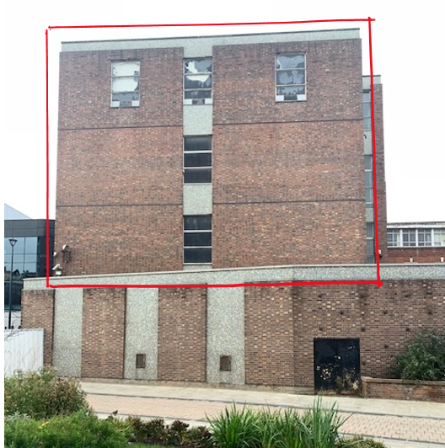

The ground floor of the building projects as shown in the images below. The condition of the roof of this section is unknown. Therefore artwork installation will require use of a boom lift or similar access platform from street level.

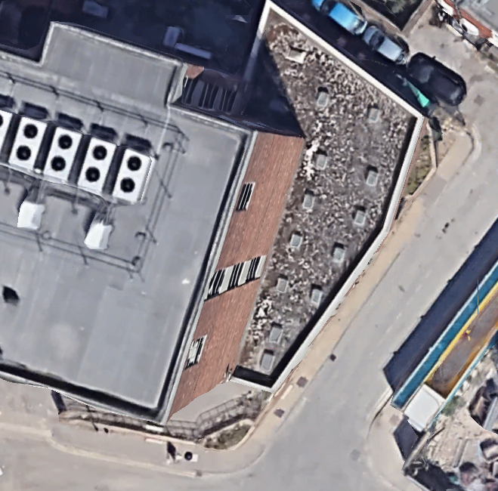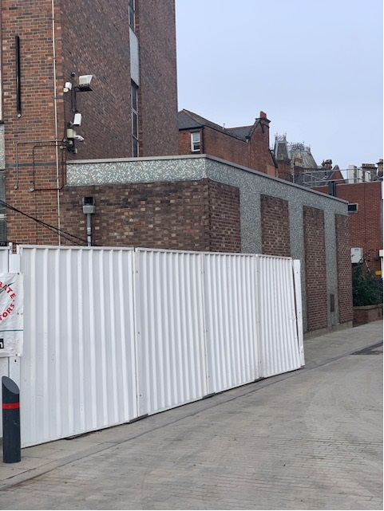
The Tiger Bar
The Tiger Bar is located within Lock-Up Yard which forms the westerly entrance to the refurbished Derby Market Hall (due to open Spring 2025). Lock-Up Yard will potentially form a spill out from the food hall within the Market and host small events. Work is scheduled to undertake repairs to the render and paintwork on the Tiger Bar to create a suitable surface for the artwork. This could also include the application of a base paint colour to the artists specification.

Themes for consideration: Lock-Up Yard is within the City Centre Conservation area and adjacent to the Garde 2 listed Market Hall. Artworks should be sensitive to this location. Historically the site has been the location of the Derby Fish Market. Lock-Up Yard is also home to a memorial to Derby County and England football legend Steve Bloomer

Dimensions. The area above the Tiger Bar entrance with windows is 6m wide by 3.6m high. Measurements for the blank wall to the left are provided in two sections; top section 7.8m wide by 3.75m high; lower section is 3.9m wide by 3m high. Designs do not need to cover the entire surface area.

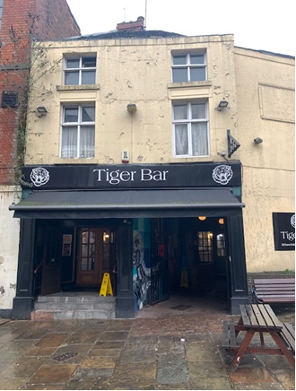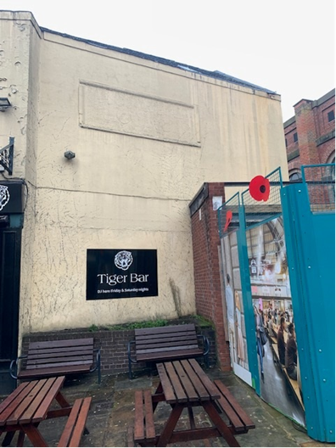
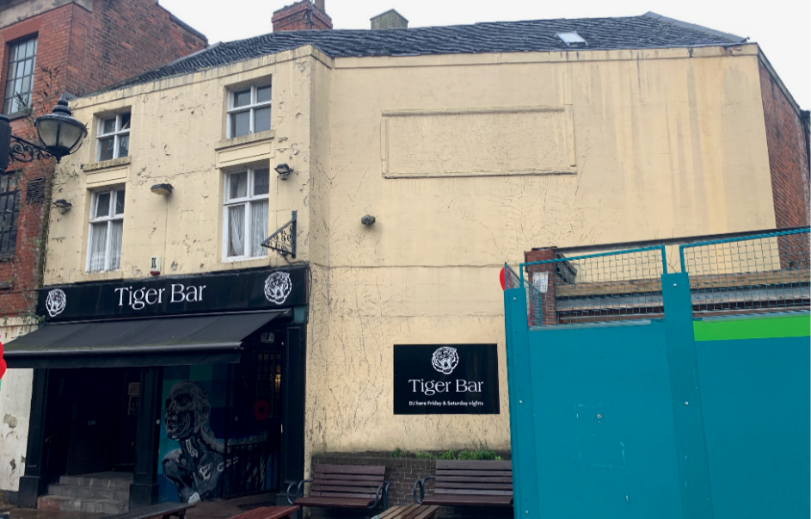
Nightingale Quarter
Expressions of interest for this location are being sought on behalf of Wavensmere Homes who would commission the artwork should suitable proposals be received.

The location is on the former site of the Derbyshire Royal Infirmary which opened in 1894 and closed 15 years ago. The Florence Nightingale-designed former hospital had lain derelict for a decade prior to Wavensmere Homes’ acquisition and start on site in 2020. The development comprises 925 new build homes and apartments, alongside community facilities in the infirmary’s iconic ‘Pepper Pot’ buildings retained and renovated within the development.

Theme: Wavensmere are keen to receive proposals depicting Florence Nightingale for either of the two walls indicated below.

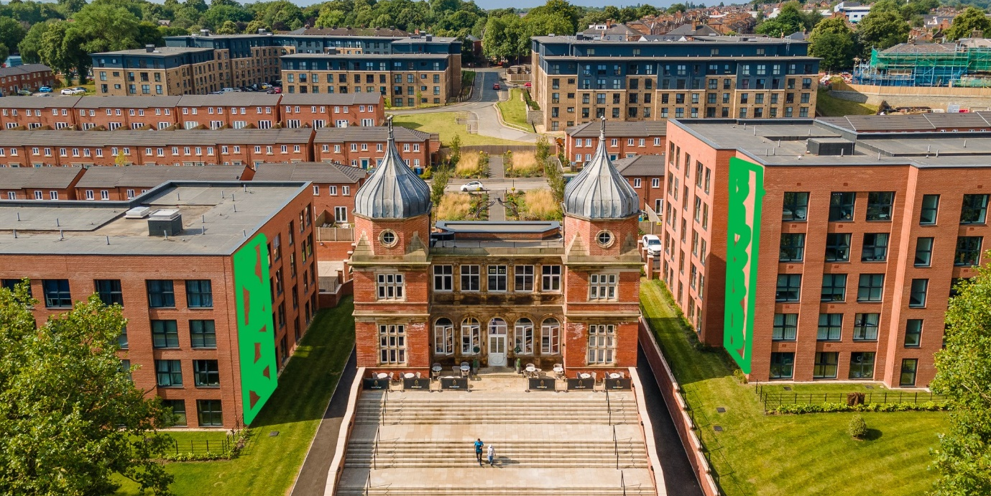

Dimensions. The wall on the left hand four storey building is 7.4m wide by 12.7m high. The wall on the right hand 5 storey building is 6.3m wide by 15.7m high. Consideration should be given to the size and position of artwork in relation to the adjacent steps which obscures the lower part of the wall from certain viewpoints, as shown in the following images.

Left Hand Building

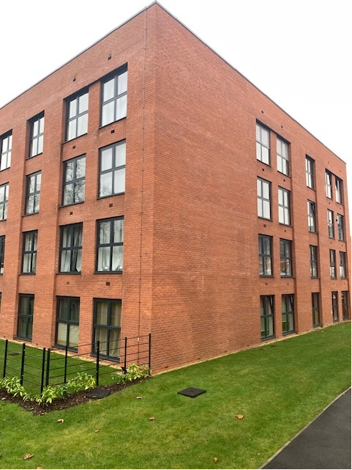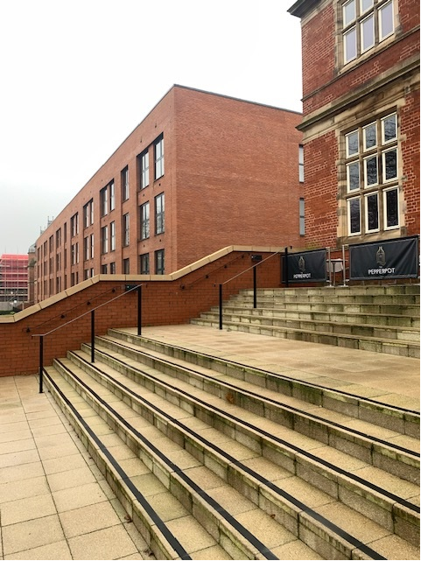

Right Hand Building

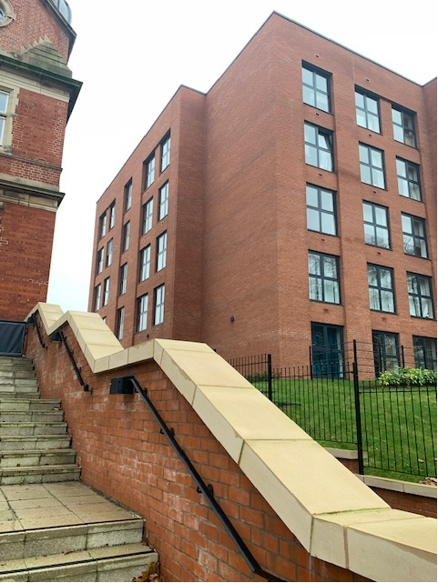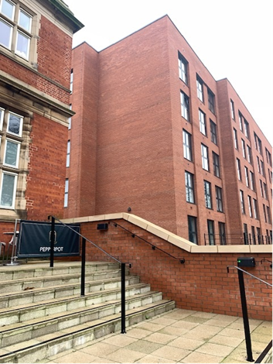

Other Locations
The buildings listed in Appendix 1 are the priority locations. However, we will consider artwork proposals for other properties within Derby city centre. It will be essential that you have permission in place from the owner of the building to complete the artwork on their property at the time of application. (NOTE the building owner will normally be different to the business occupying the property – it is the owner that must provide permission). To discuss an alternative artwork location please contact mike.brown@derby.gov.uk

