Equality impact assessment form

Directorate – Communities and Place

Service area – Planning Services

Name of policy, strategy, review or function being assessed – Revised Statement of Community Involvement

Date of assessment – 14 June 2017

Name of Director/Head of Service signing it off – Paul Clark, Head of Planning

Decision of Cabinet, Personnel Committee or Chief Officer Group

Date published on website

Please note:
Place any partner logos beneath this line. If there are no partner logos delete this box and the line.
Please note:
Place any partner logos beneath this line. If there are no partner logos delete this box and the line.

Please note:

Place your picture here.
Click on this box to select.
Go to Insert then Picture and From File.
Then source the picture you want from your folder.
Then click Insert.

Please try not to use clip art.
Please note:

Place your picture here.
Click on this box to select.
Go to Insert then Picture and From File.
Then source the picture you want from your folder.
Then click Insert.

Please try not to use clip art.
Please note:

Place your picture here.
Click on this box to select.
Go to Insert then Picture and From File.
Then source the picture you want from your folder.
Then click Insert.

Please try not to use clip art.
Please note:

Place your picture here.
Click on this box to select.
Go to Insert then Picture and From File.
Then source the picture you want from your folder.
Then click Insert.

Please try not to use clip art.
Please note:

Place your picture here.
Click on this box to select.
Go to Insert then Picture and From File.
Then source the picture you want from your folder.
Then click Insert.

Please try not to use clip art.
Please note:
Place any partner logos beneath this line. If there are no partner logos delete this box and the line.

Please note:
Place any partner logos beneath this line. If there are no partner logos delete this box and the line.

January 2017
Equality impact assessment – please read this section first before you do the assessment

This is our equality impact assessment form to help you equality check what you are doing when you are about to produce a new policy, review an older one, write a strategy or plan or review your services and functions. In fact you need to do an equality impact assessment whenever a decision is needed that affects people and before that decision is made.

So why do we need to do equality impact assessments? Although the law does not require us to do them now, the courts still place significant weight on the existence of some form of documentary evidence of compliance with the Public Sector Equality Duty when determining judicial review cases. This method helps us to make our decisions fairly, taking into account any equality implications, so yes we still need to do them.

The Public Sector Equality Duty is part of the Equality Act 2010 and this Duty requires us as a public body to have ‘due regard’ to eliminating discrimination, harassment and victimisation and any other conduct that is prohibited by or under the Act. It requires us to advance equality of opportunity and foster good relations between people who share a ‘relevant protected characteristic’ and people who don’t.

Having ‘due regard’ means:

- removing or minimising disadvantages suffered by people due to their protected characteristics
- taking steps to meet the needs of people with certain protected characteristics where these are different from the needs of other people
- encouraging people with certain protected characteristics to participate in public life or in other activities where the participation is disproportionately low.

The protected characteristics are:

- age
- disability
- gender identity
- marriage and civil partnership
- pregnancy and maternity
- race
- religion or belief
- sex
- sexual orientation
This completed form should be attached to any Chief Officer Group, Cabinet or Personnel Committee report to help elected members make their decisions by taking the equality implications into account. Equality impact assessments must be done before decisions are made. Include the Cabinet or Personnel Committee’s decision on the front sheet when you know it.

You’ll find that doing these assessments will help you to:
- understand your customers’ and communities needs
- develop service improvements
- improve service satisfaction
- demonstrate that you have been fair and open and considered equality when working on re-structuring
- make sure you pay due regard to the requirements of the Public Sector Equality Duty.

Don’t do the form by yourself, get a small team together and make sure you include key people in the team such as representatives from our Diversity Forums and employee networks and you could invite trade union representatives too – the more knowledge around the table the better. You also need to decide how and who you will consult with to help inform the equality impact assessment. Our Lead on Equality and Diversity can help with useful contacts – we have a team of people who are used to doing these assessments and can help with information on barriers facing particular groups and remedies to overcome these barriers.

You’ll need to pull together all the information you can about how what you are assessing affects different groups of people and then examine this information to check whether some people will be negatively or positively affected. Then you’ll need to look at ways of lessening any negative effects or making the service more accessible – this is where your assessment team is very useful and you can also use the wider community.

Agree an equality action plan with your assessment team, setting targets for dealing with any negative effects or gaps in information you may have found. Set up a way of monitoring these actions to make sure they are done and include them in your service business plans.

When you have completed the assessment, get it signed by your Head of Service or Service Director and send it to our Lead on Equality and Diversity for checking and to publish on our website. It is a public document so must not contain any jargon and be easy to understand.

Remember, we need to do these assessments as part of our everyday business, so we get our equality responsibilities right and stay within the law – Equality Act 2010.

Equality groups and protected characteristics

These are the equality groups of people we need to think about when we are doing equality impact assessments and these people can be our customers or our employees and job applicants…

- Age equality – the effects on younger and older people

- Disability equality – the effects on the whole range of disabled people, including Deaf people, hearing impaired people, visually impaired people, people with mental health issues, people with learning difficulties and people with physical impairments

- Gender identity – the effects on trans people

- Marriage and civil partnership equality

- Pregnancy and maternity equality - women who are pregnant or who have recently had a baby, including breast feeding mothers

- Race equality – the effects on minority ethnic communities, including newer communities, gypsies and travellers and the Roma community

- Religion and belief or non-belief equality – the effects on religious and cultural communities, customers and employees

- Sex equality – the effects on both men and women and boys and girls

- Sexual Orientation equality – the effects on lesbians, gay men and bisexual people

Contact for help

Ann Webster – Lead on Equality and Diversity
ann.webster@derby.gov.uk
Tel 01332 643722 Minicom 01332 640666 Mobile 07812301144

The form

We use the term ‘policy’ as shorthand on this form for the full range of policies, practices, plans, reviews, activities and procedures.

Policies will usually fall into three main categories…

- Organisational policies and functions, such as recruitment, complaints procedures, re-structures

- Key decisions such as allocating funding to voluntary organisations, budget setting

- Policies that set criteria or guidelines for others to use, such as criteria about school admissions, procurement methods, disabled facilities grants, on street parking bays

If in doubt – it’s better and safer to do an Equality Impact Assessment than not to bother! You never know when we may get a legal challenge and someone applies for Judicial Review.

What’s the name of the policy you are assessing?

Revised Statement of Community Involvement

The assessment team

Team leader’s name and job title – Nicky Bartley, Planning Policy Team Leader

Other team members

Name | Job title | Organisation | Area of expertise
David Brown | Senior Planning Officer | DCC – Planning Services | Planning Policy & Consultation
Nicky Bartley | Planning Policy Team Leader | DCC – Planning Services | Planning Policy
Ian Woodhead | Planning Manager | DCC – Planning Services | Development Control
Sheila Mitchell | Senior Planning Assistant | DCC – Planning Services | Planning Policy & Consultation
Som Bhalla |  |  | Minority Communities/Disabled People’s Forum
Judi Bateman |  |  | Disabled People’s Forum
Dr Didier Matamba |  |  | Minority Communities Forum
Lukasz Gazda |  |  | Minority Communities Forum
Pam Thompson | Adults & Diverse Communities Participation Officer | Derby City Council | Diversity
Ann Webster | Equality and Diversity Lead | Derby City Council | Equality and Diversity Lead

Step 1 – setting the scene

Make sure you have clear aims and objectives on what you are impact assessing – this way you keep to the purpose of the assessment and are less likely to get side tracked.

- What are the main aims, objectives and purpose of the policy? How does it fit in with the wider aims of the Council and wider Derby Plan? Include here any links to the Council Plan, Derby Plan or your Directorate Service Plan.

The core aim of the Statement of Community Involvement (SCI) is to ensure that everyone has an opportunity to engage with the various aspects of planning services and have a positive input into any decisions.

The SCI covers two aspects of planning in the City:

- The production of the Council’s statutory development plan which includes the Local Plan, Supplementary Planning Documents and Neighbourhood Planning. Engaging with the wider community is a fundamental aspect in the preparation of the local plan as an independent planning inspector assesses the ‘soundness’ of the plan against the SCI. The SCI also takes account of the Council’s adopted Communications Strategy.

- Commenting on planning applications for all types of development in the City
- Who delivers/will deliver the policy, including any consultation on it and any outside organisations who deliver under procurement arrangements?

All planning officers are expected to accord with the Statement of Community Involvement; either through the development of the Council’s statutory plan or when consulting on a planning application.

The Revised SCI is based on an earlier, adopted document. It has been updated to take account of changes to various planning regulations (which we have to accord with) and the emergence of new consultation techniques.

The SCI has also been developed with the assistance of colleagues from the Council’s Corporate Communications Team to ensure that the SCI reflects the aspirations of the adopted Communications Strategy as far as practicable.

The SCI has also been subject to a wide –ranging consultation exercise and has been amended to reflect a number of comments the Council received.

- Who are the main customers, users, partners, employees or groups affected by this proposal?

Users - all planning officers will be required to follow the Statement of Community Involvement.

Customers – those applying for planning permission or commenting on planning applications and those engaging with the preparation of planning policy.

Groups – those that seek to represent areas of the City or particular interest groups who interact with the planning system; for example, residents associations.

Step 2 – collecting information and assessing impact

4 Who have you consulted and engaged with so far about this policy, and what did they tell you? Who else do you plan to consult with? – tell us here how you did this consultation and how you made it accessible for the equality groups, such as accessible locations, interpreters and translations, accessible documents.

Having an SCI is a requirement of the Planning and Compulsory Planning Act 2004. Consultation on preparing or revising an SCI, consulting on a planning policy document or consulting on a planning application is set out in the Town and Country Planning (Local Planning) (England) Regulations 2012 or the Town and Country Planning (Development Management Procedure) (England) Order 2015.

The revised SCI was based on a document which went through a statutory process and was examined by an independent planning inspector. This revised document follows the same basic principles but now takes account of, for example, new consultation methods. The revised SCI also takes account of the results of various consultations held since 2007.

The consultation met the requirement of the regulations. It lasted for six weeks and was publicised through Your City Your Say, internally through In Touch, corresponding with everyone on the LDF Database (people and organisations who have commented on, or wished to be kept informed on the progress of the Local Plan. In addition, anyone who submitted a planning application since 2015 was informed. Finally, statutory bodies such as Natural England, Heritage England and the Environment Agency. In addition, neighbouring local authorities and designated Neighbourhood Planning Groups were also informed.

Documents were made available on-line and printed versions of the document were placed in local libraries and at the Council House. People could also request printed versions in a variety of formats of the SCI and comments form to be sent to them free of charge.

Responses in summary:

- Statutory bodies who did respond supported the revisions to the SCI
- The Woodlands Trust requested that they are informed of every application which affect an ancient woodland
- Breadsall Parish Council requested that they are informed of planning applications which are adjacent to their parish.
- The Darley Abbey Society sought further clarification of the timescales involved in the preparation on statutory documents as they differed from those set out in the Council’s Communication Strategy.
- The Darley Abbey Society also sought clarification on certain procedural aspects of the Development Management process

- Three members of the public also submitted individual comments
- One just stated an objection to the SCI but gave no reasons or suggested amendments.

- Two members of the public stated that, in practice, both officers and members do not take into account the views of the community.

5 Using the skills and knowledge in your assessment team, and from any consultation you have done, what do you already know about the equality impact of the policy on particular groups? Also, use any other information you know about such as any customer feedback, surveys, national research or data. Indicate by a tick for each equality group whether this is a negative impact, a positive one or if you are not sure

Equality groups | What do you already know? | No impact | Positive impact | Negative impact | Not sure
Age | Some older people are less likely to have access to the internet. The offer of large print documents and other formats, organising events in easily accessible locations, holding face-to-face meetings and working with community groups and other stakeholders are included in the SCI. |  | √
Disability | Consultation on planning policy documents and notification of planning applications are often not accessible for disabled people, particularly those with visual impairments. We will arrange for these to be made accessible on request as part of our responsibilities under the Equality Act 2010 and our Accessible Communication Protocol Some disabled people may also find it difficult to access meetings or events, despite them, being held in accessible venues and we will do all we can to deal with requests for help to access the documents.  We know that Derby has largest population of Deaf people outside of London and we also know that many Deaf people cannot access the information we provide – one way to reach Deaf people in the community is to work with our local British Deaf Association Officer and Derby Deaf Club in line with our Deaf and Hearing Impaired people’s Commitment .  We will arrange for face-to-face discussions and meetings to help access information, with BSL interpreters present on request  The SCI and other planning policy documents are produced as electronic or printed versions. Meetings and events are held, in accessible buildings. Engaging with community groups, the Derby Disability Forum and holding face-to-face meetings at an early stage in the plan preparation process will address this. |  | √
Gender identity - trans | Work with the Diversity forums to engage with LGBT groups, such as Derbyshire LGBT+ | √
Marriage and civil partnership | No adverse implications identified | √
Pregnancy and maternity | Heavily pregnant women may find it difficult to get to planning events, but we will explore other ways of getting information across to them | √
Race | Engaging with minority ethnic community groups, the Derby Diversity Forum and holding face-to-face meetings help us to engage with people who have English as another language  On request, the Council will provide material in alternative languages. |  | √
Religion or belief or none | In planning policy, we will be mindful of religious beliefs when scheduling meetings or running consultations.  Development Management have set timescales for determining planning applications but are mindful of religious beliefs when scheduling meetings. |  | √
Sex | No adverse implications identified | √
Sexual Orientation | Work with the Diversity forums to engage with LGBT groups, such as Derbyshire LGBT+ | √

Important - For any of the equality groups you don’t have any information about, then make it an equality action at the end of this assessment to find out. This doesn’t mean that you can’t complete the assessment without the information, but you need to follow up the action and if necessary, review the assessment later. You can get lots of information on reports done from organisations’ websites such as the Equality and Human Rights Commission, Stonewall, Press for Change, Joseph Rowntree Trust and so on. Please don’t put down that the impact affects ‘everyone the same’ – it never does!

6 From the information you have collected, how are you going to lessen any negative impact on any of the equality groups? How are you going to fill any gaps in information you have discovered?

We will work with our Diversity Forums, in consulting on planning policy documents such as the Local Plan, to look at how we can engage with the LGBT community. We will make sure all our staff are aware that they must endeavour to provide information in other formats on request. We will also ask if Derby Deaf Club wish to be advised of planning applications via the weekly list.

Step 3 – deciding on the outcome

7 What outcome does this assessment suggest you take? – You might find more than one applies. Please also tell us why you have come to this decision?

Outcome 1 | √ | No major change needed – the EIA hasn’t identified any potential for discrimination or negative impact and all opportunities to advance equality have been taken
Outcome 2 |  | Adjust the policy to remove barriers identified by the EIA or better advance equality. Are you satisfied that the proposed adjustments will remove the barriers you identified?
Outcome 3 |  | Continue the policy despite potential for negative impact or missed opportunities to advance equality identified. You will need to make sure the EIA clearly sets out the justifications for continuing with it. You need to consider whether there are:  - sufficient plans to stop or minimise the negative impact  - mitigating actions for any remaining negative impacts  - plans to monitor the actual impact.
Outcome 4 |  | Stop and rethink the policy when the EIA shows actual or potential unlawful discrimination

Our Assessment team has agreed Outcome number(s)

Outcome 1

Why did you come to this decision?

This is a refresh of an existing document and the fundamental principles which were found sound by a government inspector have not changed. However, new consultation methods the revised SCI has embraced ensures that the wider community will be aware of any planning consultation.

If you have decided on Outcome 3, then please tell us here the justification for continuing with the policy. You also need to make sure that there are actions in the Equality Action Plan to lessen the effect of the negative impact. This is really important and may face a legal challenge in the future.

If you have decided on Outcome 4 then if the proposal continues, without any mitigating actions, it may be likely that we will face a legal challenge and possibly a Judicial Review on the process - it is really important that the equality impact assessment is done thoroughly, as this is what the Judge will consider.

Step 4 – equality action plan – setting targets and monitoring

8 Fill in the table (on the next page) with the equality actions you have come up with during the assessment. Indicate how you plan to monitor the equality impact of the proposals, once they have been implemented.

Equality Action Plan –setting targets and monitoring
What are we going to do to advance equality | What difference will it make | When will we do it and who will lead | Monitoring arrangements
Inform all employees, external bodies and the Council’s Forums of the adoption of the revised Statement of Community involvement | It will make sure as many people as possible knows about our Statement and commitment to work with the community on planning | Dave Brown/Sheila Mitchell
Continue to monitor the demography of participants and consider how to increase participation from any under-represented groups | To determine if the SCI is working or if an early review is necessary | Dave Brown | Monitored after each consultation
Review the consultation methods at the end of each consultation. | To determine if the consultation methods used are effective or if any changes need to be implemented. | Dave Brown | Monitored after each consultation
Through the Diversity Forums, work with Derbyshire LGBT+ to find out the implications for the LGBT community | It will make sure we address any LGB and Trans issues | Dave Brown/Pam Thompson
Make sure all Planning employees are aware of our Accessible Communications Protocol on iDerby | It will mean that access to information is fully taken into account and more citizens will be able to comment on Planning applications | Dave Brown
Through the Diversity Forums, work with the British Deaf Association and Derby Deaf Club to establish how best Deaf and hearing impaired people can access planning applications. | It will mean that Deaf people will have a chance to comment on planning applications | Dave Brown/Ann Webster
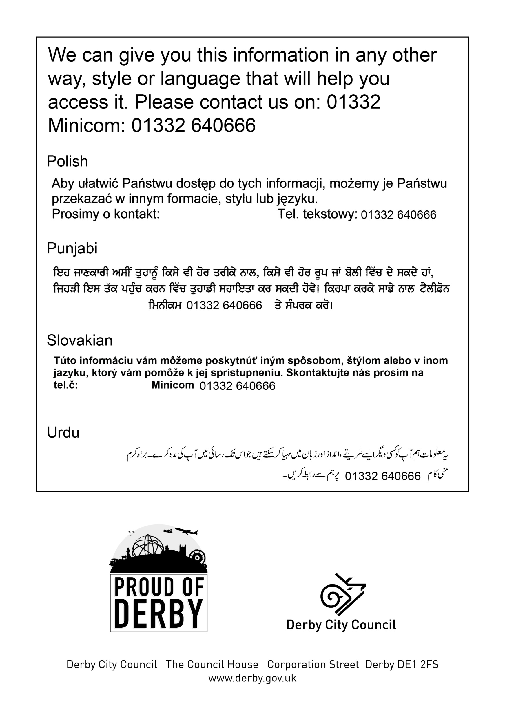
643722

01332 643722

01332 643722

01332 643722

01332 643722

