Public Sector Equality Duty -
Equality, Diversity and Inclusion Information 2024/2025

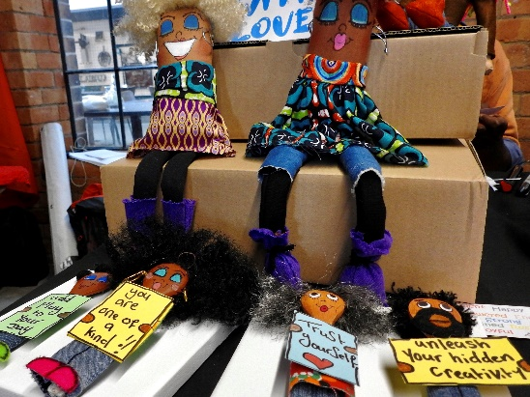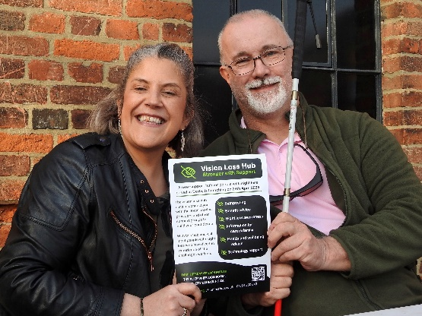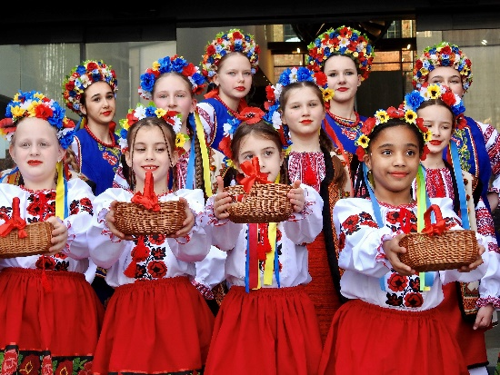

1 Introduction
This booklet outlines our achievements in meeting our legal obligations under the Public Sector Equality Duty up to July 2025.
Every year, public authorities like us must publish this information, along with equality statistics about our employees and job applicants – the employment information is in a separate document Working for Derby City Council Employment Statistics 2023 to 2024
The Public Sector Equality Duty has three main aims which are to:
- eliminate unlawful discrimination, harassment, victimisation and any other conduct that is prohibited by or under the Act
- advance equality of opportunity between people who share a protected characteristic and those who do not
- foster good relations between people who share a protected characteristic and those that who do not.
These are sometimes called the three aims or arms of the general equality duty.
Advancing equality of opportunity means having ‘due regard’ to equality in everything we do including:
- removing or minimising disadvantages suffered by people due to their protected characteristics
- taking steps to meet the needs of people from protected groups where these are different from the needs of other people
- encouraging people from protected characteristics to participate in public life or in other activities where their participation is disproportionately low.
2 What we’ve achieved in 2024
Equality is embedded in all our work and in our main Council documents such as our Council Plan 2022/2025.
In addition, Scrutiny - Derby City Council take equality extremely seriously and it is part of their everyday work when they are scrutinising services.
So, during 2024 our Equality, Diversity and Inclusion Board, Employee Networks and our Equality Hubs and Forums spent lots of time producing our Equality, Diversity and Inclusion Plan 2025 to 2028. At the same time, External Audit, audited our previous 2021 to 2024 Plan and we were delighted to get this result…
‘Substantial - There is a sound system of governance, risk management and control exists, with internal controls operating effectively and being consistently applied to support the achievement of objectives in the area audited’
So, now we are adding in roles and responsibilities for the new 2025 to 2028 Plan and producing a detailed Action Plan to sit alongside it. This will be monitored at each Equality, Diversity and Inclusion Board meeting and progress reported to our Corporate Leadership Team.
Poverty Action Group
We have a Poverty Action Group which also addresses equality and diversity in its work both for our colleagues and the residents of Derby. The Group is chaired by a Council Cabinet Member who leads on Cost of Living, Equalities and Communities.
We’ve added Socio Economic Duty Implications to our report templates so that report authors think about their proposals and how it affects people on low incomes. We’ve also added Socio Economic Implications into our Equality Impact Assessment Template too.
We are currently producing an Anti-Poverty Strategy for Derby and have had support and advice from the Equality Trust to hold two sessions with members of our community. The events were very successful and gave us that hugely essential ‘lived experience’ prospective that we need when pulling the Strategy together.

Equality, Diversity and Inclusion Board
Our Equality, Diversity and Inclusion Board is co-chaired by three Directors and attended by Service Directors and Heads of Service as well as representatives of our Employee Networks – the Board reports directly to our Corporate Leadership Team and oversees and monitors our equality, diversity and inclusion work. The Board continues to provide governance at a senior level of our Equality, Diversity and Inclusion Agenda and is supported by the commitment of our Corporate Leadership Team.
Equality Hubs and Forums
We strongly believe in the saying ‘nothing about us, without us’ and so our community groups are extremely important to us. Our 60+ Forum, Access, Equality and Inclusion Hub with Parks sub-group and our LD Voice Partnership Board continue to meet to help us with our equality agenda.
Our Race Equality Hub is being refreshed and we have already held a meeting with members to look at a new approach.
We have started to have blended and hybrid meetings now to try to meet our Equality Hubs members’ needs. In addition, we have Voices in Action Young People’s Forum. We also have our Deaf and Hard of Hearing People’s Commitment Group who help us make sure we work to the Commitment we signed up to in 2013.
The British Deaf Association has recently relaunched their BSL Charter to be called the Sign Language Charter and so we will be working towards the new pledges in this new approach. In addition, our Deaf and Hard of Hearing People’s Commitment Group has now been renamed to be the Deaf and Deafblind People’s Equality Hub.
We liaise with women’s groups in our community and our local Derbyshire LGBT+. The Equality Hubs meet every three months and are chaired by a Councillor Champion. The Hubs comprise representatives of community and diverse organisations and individuals who help us to check our policies and procedures are working and members regularly take part in Equality Impact Assessments. We usually have two items on the agenda or themed meetings so we can discuss issues in detail.
Community Safety
- The team administered the Community Cohesion and Resilience Programme grant from MHCLG. The grant provided 10 community groups/organisations with up to £5000 to deliver projects providing an opportunity to bring communities together to improve cohesion and reduce divisions in places facing extremism challenges.

- We worked with Community Action Derby to fund and develop the New Arrivals Alliance (NAA). The NAA will support all stakeholders in Derby to work together to provide early access to support for asylum seekers and resettled refugees to assist their orientation and integration. The New Arrivals Alliance was recently mentioned as an example of best practice in parliament at a Home Affairs Committee on Asylum Accommodation, by the British Red Cross's UK Director for refugee support and restoring family links, Alex Fraser.

- We funded the Association of Ukrainians to develop and deliver a programme of activities to support integration and to build trust within communities with statutory services.

Access for Disabled people
The Access, Equality and Inclusion Hub continues to advise and support us with access improvements. The Parks Sub-Group Chair works tirelessly on a voluntary basis to make sure we have plans to have inclusive play equipment in them. As a result of this he was nominated for the Equality, Diversity and Inclusion Champion Award in the Community Action Derby Awards and won in recognition of all the access support he offers us. In addition, we secured funding for more Changing Places toilets on our parks and in the city centre. The Hub’s input was invaluable.
So, during 2024 our Parks Team installed more inclusive play equipment in our parks and changing places toilets, and we advised our local shopping centre about inclusive equipment for their small play area they are building. Feedback from disabled children and parents and carers has been brilliant – to see a child who is a wheelchair user use the inclusive swing and seesaw is job satisfaction at its best!
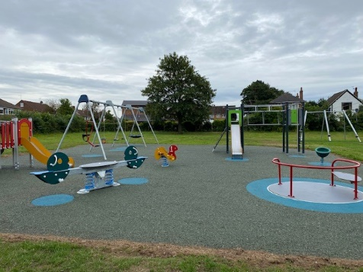

Derby Parks continue to improve inclusivity and accessibility on the city’s parks and over the last year we have completed footpath improvements across a number of sites including Chaddesden Park, Alvaston Park and Allestree Park. One of the best access improvements was the South Avenue Park and Gravel Pit Recreation Ground footpath works – these works have created an accessible tarmac footpath through these two spaces on a popular route. New accessible kissing gates, at the entrances to Chaddesden Wood have improved accessibility into this ancient woodland.
In November 2024 new inclusive play equipment was installed at Markeaton Park. The new wheelchair accessible swing is the first in Derby and has been installed alongside a wheelchair accessible seesaw and musical play items. The new accessible and inclusive play area at the Arboretum opened in April 2025. Following detailed engagement with the local community, and charities and organisations representing disabled people the design was focused on creating a play space for all. The new play area has a roundabout, seesaw and trampoline all of which are wheelchair accessible, inclusive swings, musical and tactile equipment and a sensory footpath. There is a yellow navigation line through the play area to aid people with a visual impairment. Improvements to the play area at Bramblebrook Recreation Ground play area have improved inclusivity of this facility with an inclusive seesaw, tactile and musical play panels and surfacing works. In May 2025 the new play area at Brunswood Park was opened – this site includes a wheelchair accessible roundabout, inclusive seesaw and springer, inclusive swings and a range of tactile and musical play elements.

We have other projects where we have involved disabled people from the start, such as our new Entertainment Arena- Vaillant Live and our Grade 11 listed Market Hall refurbishment where we commissioned Mik Scarlett, who is a well-known presenter and trainer of disability equality to train all staff involved at the planning stage. Mik, of course came to our opening event. Since opening, The Market Hall has become a hub of activity for diversity events too. And the Market Hall Team and traders are looking to learn some basic Sign Language to support our Deaf customers.
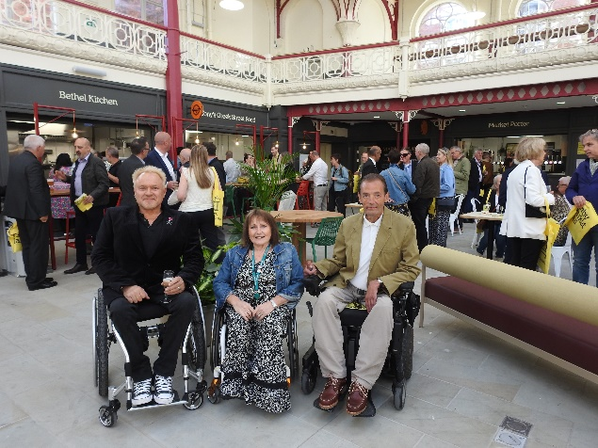
Our Street Café Licensing Policy states no access for disabled people, then no licence. Each application is checked for access to make sure they are accessible for disabled people and do not obstruct the pavement.
We continue to check on blue badge abuse in the city. Our Civil Enforcement Officers go on regular patrols accompanied by some of our Equality Hub members to target blue badge abusers. They have recently won an award for their enforcement work and safe school zones.
Carers
Carers do invaluable work for the people they care for, in our communities and wider society, contribute billions of pounds each year to our economy and underpin health and social care services which could not manage, practically financially, without them. However, carers can often experience significant challenges to their health, wellbeing and financial situation and often find themselves isolated and excluded from their communities.

Derby City Council has continued to recognise the important of supporting carers over the last year including through:

- working with Health, Voluntary and Community Sector and other partner organisations to ‘Think Carer’ whenever they are interacting with a vulnerable customer – to help us identify and connect with people who are caring for others

- improving the carers’ support process so that people who contact the Council, our partners and the Derby City Universal Service for Carers get more appropriate support and much more quickly within the community – making sure that all carers looking for support are first referred into the Universal Service for carers and only those whose support needs cannot be met by the service or other community partners come to adult social care for a formal carers assessment – also meaning those who really need it get a formal assessment more quickly

- working with informal carer support groups across the City, recognising that carers gain a huge amount from peer support with other carers who understand what they are going through and have experience and advice they can share

- using Department of Health and Social Care funding to commission Community Action Derby to lead a project (with Universal Service for Carers, other partners and people with lived experience) on how we improve support for carers from diverse communities, who currently struggle to access support or cannot get the support they need.

Celebrating and marking diversity
We continue to celebrate and mark national and international days, such as International Women’s Day, World AIDS Day, International Day against Homophobia, Biphobia and Transphobia, LGBT History Month, LGBT Fostering and Adoption Month, Black History Season, International Day of Disabled People, Stephen Lawrence Day, National Interfaith Week and Holocaust Memorial events and many more. For World AIDs Day, each year we set up a working group to plan out how we will mark the day with a co-ordinated approach, and this has worked out very well and the day is usually a huge success. We also cover our AIDs Memorial tree with red ribbons. We change our Council logo so that it is also wearing a red ribbon on our social media posts.
For Interfaith Week, we work with Derby’s Multifaith Centre to celebrate the many religions and beliefs we have in Derby.
Each year, Holocaust Memorial Day is planned by our community working together and they put on some very moving events.
To mark International Day of Disabled People, we focus on different schemes each year and hidden impairments has been one of them and we advertised the fact that we have used signage to remind people not to judge other disabled people. We’ve used ‘Remember you can’t always tell if someone is a disabled person’ These signs are on all our accessible toilets now.

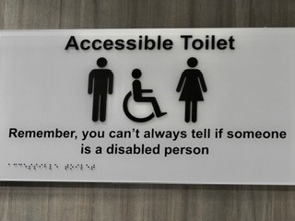

We continue to be a key partner with International Women’s Day Derby who put on a very successful event at Derby Museum of Making in March 2025. This is always a very inclusive event and a chance for lots of networking.

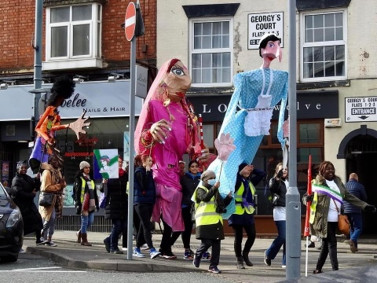
We provided the BSL interpreters for the event, which included a peaceful march through the city centre with huge puppets of famous women, including our own Suffragette Alice Wheeldon.
We have worked very positively with our LGBTQ+ community on fostering and adoption and mark LGBT Fostering and Adoption Week with lots of media coverage. We’ve also raised awareness in our Black communities through our Race Equality Hub to encourage more Black people to foster.
We always mark International Day against Homophobia, Biphobia and Trans phobia with a flag raising ceremony and some supportive messages to our LGBTQ+ Community. This year it was particularly important as the Supreme Court Ruling had just been issued on gender and what it means in the Equality Act and so our LGBTQ+ community are feeling very low. We read out some poems and our Cabinet Member for Cost of Living, Equalities and Communities gave a message of support and solidarity.
Derby Pride 2024 was a great success again and we are planning to be at Derby Pride 2025 and will provide the BSL interpreters for the event, as we have done for many years.
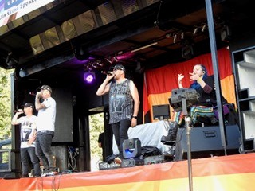
We are currently reviewing our Diversity Calendar to concentrate more on specific events rather than have so many dates that we cannot do them all justice.
Employee Networks
Our Disabled Employees and Carers Network worked on a new system and form for reasonable adjustments which is now live. This was following feedback from members. We have a Fibromyalgia Sub-Group which is going well and have launched a Neurodiversity Group at the request of some of our Neurodivergent colleagues. They have been working closely with our Facilities Management colleagues to make our workplace environment more neurodiversity friendly.
Our Black, Asian and Minority Ethnic Employees Support Network is growing from strength to strength and organised a successful event for Black History Month in October 2024. The event consisted of a Panel question and answer session, and feedback was brilliant and very encouraging. The Network has a Newsletter and Action Plan.
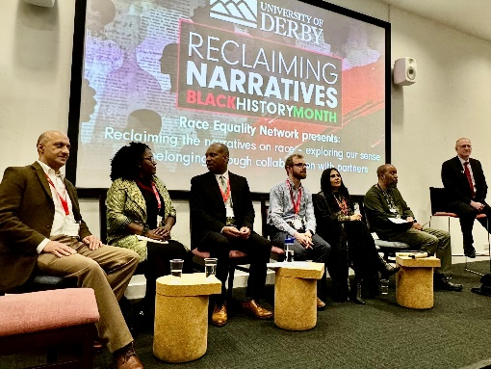

Our LGBTQ+ and Allies Employee Network has been meeting virtually, and face to face and plan events to raise awareness of LGBTQ+ Equality. They have a regular newsletter on-line to let our colleagues know of events and articles of interest to read. We continue to fly the Pride in Progress and Trans flags on key events. We also mark Bi-Visibility Day too and LGBT History Month as well as International Day against Homophobia, Biphobia and Transphobia. In addition, we had to purchase some more rainbow badges and trans equality badges for colleagues to wear on their lanyards as they have gone down so well. We have also signed up to Derbyshire LGBT+ Rainbow Accreditation scheme to work through various actions to be accredited.
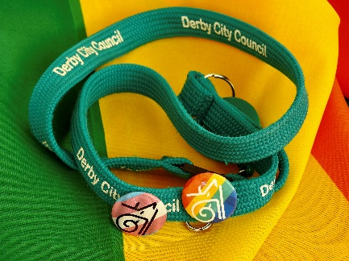
As part of Pride Month the Network has planned and launched an arts competotion for children and young people and the entries will be displayed in Derby Market Hall and the winner announced at Derby Pride in September.
We also have a Menopause Friends Group for Council colleagues which has proven to be very successful.
Influencing others
We regularly use our Public Sector Equality Duty to challenge discrimination and advance equality in outside bodies, such as in access for disabled people and LGBTQ+ equality. We know we do not have the powers to police the Equality Act, but we can do all we can to try to encourage other agencies to work to equality legislation and beyond.
When we receive customer complaints and feedback, if any of these are in relation to an equality and diversity issue, they are automatically passed to our Lead on Equality and Diversity to examine. Sadly, we get complaints about us flying the Pride in Progress Flag and we deal with these in a professional manner. We do still fly the flag as this is an important symbol of LGBTQ+ equality.
We continue to work with three third party providers to provide all our interpretation and translation requirements, apart from Easy Read and British Sign Language - we use an organisation who works with people with learning difficulties to do our Easy Read and local suppliers of British Sign Language Interpreters.
We provide Deaf Equality Courses for colleagues and basic BSL courses for our customer facing colleagues – these are being delivered by our own Adult Learning Service and other agencies.
As Disability Confident Leaders of the DWP’s Disability Confident Scheme we continue to support other employers who also want to take part.
Our People Services are embracing equality, diversity and inclusion by recruiting colleagues to become Equality and Diversity Influencers and this is going to be started up across the rest of the Council too.
Equality impact assessments
` We still believe strongly in involving community representatives to help us with our equality impact assessments and these are published on our equality webpages. Despite equality impact assessments no longer being a legal requirement, we believe that they help us to demonstrate that we are paying ‘due regard’ to equality in our decision making. As well as adding social economic implications to our EIA template we have now also added care experienced too.
The Hubs and Employee Networks are invaluable during our budget equality impact assessments. We usually set up an EIA Panel who scrutinise the EIAs that colleagues have completed. On one occasion, the EIA Panel found four budget proposals that they recommended ‘stop and think again’. Three out of these four proposals identified did not go ahead, thanks to the work of the Panel and the power and influence of equality impact assessments.
Greenery and somewhere to sit and rest and reflect in the city centre
Over the last few months our Mobility Programme Team, have been installing inclusive benches with planters all around the city centre. These benches have been a huge success with shoppers and with businesses. One of our Access Hub members just happened to mention we could do with a bench outside the Council House and from then on, our Team went into action.
So, the benches have been carefully designed to be inclusive with armrests to help older people and disabled people use them easier. The armrests are colour contrasts with the benches too to make them more accessible for visually impaired people. Many of the plants chosen provide a sensory experience too.
One of the benches has been designed specifically to be a memory bench, so we can remember colleagues we have lost in service, but also for anyone visiting our city to remember loved ones too. We have included these examples of benches in this booklet to demonstrate how our colleagues naturally think ‘equality and inclusion’ in their everyday work.
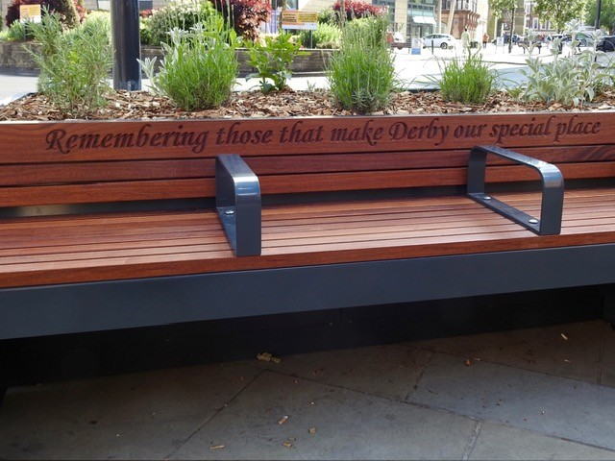

3 Our new equality objectives for 2025/2028
As our previous three year equality objectives came to an end in 2024, we prepared, discussed and finalised our Equality, Diversity and Inclusion Plan 2025 to 2028 We had huge amounts of support, help and input from our Employee Networks and Equality Hubs and Forums and finalised by our Equality, Diversity and Inclusion Board who had also ran a few workshops so we could get our new Plan how we all wanted it.
So here are the new five equality objectives we came up with
Equality objective 1- Leadership
Leaders, across the organisation actively embrace equality, diversity, inclusion and compassion and make fair, accessible and inclusive decisions.
This objective is all about how Leadership embraces equality, diversity, and inclusion in the way the Council is managed.
Equality Objective 2 – Communities
Strengthen meaningful inclusive engagement between the Council, colleagues, volunteers, communities, neighbourhoods, groups and individuals, fostering good relations between them as part of our Public Sector Equality Duty. This is about our role in the community and how we tackle hate crime and promote understanding amongst communities.
Objective 3 – Partnerships
Coordinate effective joint working on equality, diversity and inclusion with other statutory agencies and partners. Use our Public Sector Equality Duty to be an influencer for change to external organisations in their equality, diversity and inclusion journey. This is about how we work together with our partners to provide a more consistent approach on equality, diversity and inclusion with our joint customers - for example bus services, businesses in Derby
Objective 4 – Removing barriers to our services
Maximise people’s ability to access our services, identifying and removing barriers to inclusion This is about how we check on how we are delivering and commissioning our services by equality monitoring and talking to our customers and Equality Hubs and Networks about what they think about our services and how we can remove any barriers. Our services need to be designed ‘with’ people and not ‘for’ people
Objective 5 – Diverse workforce
Champion diversity at all levels across our workforce, so we are representative of our communities, promoting colleague understanding and accountability for equality, diversity and inclusion. This objective is about our role as an inclusive employer and making sure our colleagues can be themselves at work.
British Deaf Association - Sign Language Charter
As mentioned earlier we will be looking into adopting the new Charter as we get more details about the newly designed pledges.
4 Monitoring and moving forward
We have just set up our Equality, Diversity and Inclusion Board made up of key senior colleagues who have the authority to make change. The Board also includes colleagues from our Employee Networks and reports to our Senior Leadership Team. A major function of the Board is to oversee the work of the Equality, Diversity and Inclusion Plan 2025/2028 to make sure it is delivered.

This booklet is on our internal website MiDerby and on our external website at www.derby.gov.uk

For more details please contact our Lead on Equality and Diversity on 01332 643722, Mobile 07812301144 or Relay UK 18001 01332 643722 derby.gov.uk/signing-service/ or ann.webster@derby.govuk

We can give you this information in any other way, style or language that will help you access it. Please contact us on 01332 643722 mobile 07812301144 or derby.gov.uk/signing-service/

Punjabi
ਇਹ ਜਾਣਕਾਰੀ ਅਸੀਂ ਤੁਹਾਨੂੰ ਕਿਸੇ ਵੀ ਹੋਰ ਤਰੀਕੇ ਨਾਲ, ਕਿਸੇ ਵੀ ਹੋਰ ਰੂਪ ਜਾਂ ਬੋਲੀ ਵਿੱਚ ਦੇ ਸਕਦੇ ਹਾਂ, ਜਿਹੜੀ ਇਸ ਤੱਕ ਪਹੁੰਚ ਕਰਨ ਵਿੱਚ ਤੁਹਾਡੀ ਸਹਾਇਤਾ ਕਰ ਸਕਦੀ ਹੋਵੇ। ਕਿਰਪਾ ਕਰਕੇ ਸਾਡੇ ਨਾਲ ਇੱਥੇ ਸੰਪਰਕ ਕਰੋ: 01332 643722 mobile 07812301144 ਜਾਂ derby.gov.uk/signing-service/

Polish
Aby ułatwić Państwu dostęp do tych informacji, możemy je Państwu przekazać w innym formacie, stylu lub języku. Prosimy o kontakt: 01332 643722 mobile 07812301144 lub derby.gov.uk/signing-service/

Slovak
Túto informáciu vám môžeme poskytnúť iným spôsobom, štýlom alebo v inom jazyku, ktorý vám pomôže k jej sprístupneniu. Prosím, kontaktujte nás na tel. č.: 01332 643722 mobile 07812301144 alebo na stránke derby.gov.uk/signing-service/

Urdu
یہ معلومات ہم آپ کو کسی دیگر ایسے طریقے، انداز اور زبان میں مہیا کر سکتے ہیں جو اس تک رسائی میں آپ کی مدد کرے۔ براہ کرم mobile 07812301144 01332 643722 یا derby.gov.uk/signing-service/ پر ہم سے رابطہ کریں

