PP+ Policy
2026-27


Introduction

The arrangements for Pupil Premium for Looked After Children (CLA) are now well established nationally and there is a commitment that this funding will remain in place for this parliament.
Throughout our policy, the Pupil Premium for CLA will be referred to as Pupil Premium Plus to distinguish it from other forms of Pupil Premium.
- The overall grant allocated to each Local Authority (LA) is calculated on a per capita basis at £2,690 per child. However, it does not have to be distributed on a per capita basis, given that CLA in care have differing levels of need at different stages of being in care
- CLA will be eligible as soon as they enter care
- LAs are responsible for Pupil Premium Plus payments with the Virtual School Headteacher (VSH) being responsible for making sure there are effective arrangements in place for its allocation
- Derby City have an electronic Personal Education Plan (ePEP). It is through the Targets page of the ePEP that the costs attributed to Pupil Premium Plus are identified and agreed
- Regular feedback on the quality of PEPs is sent from the Virtual School to designated teachers and social workers using the Notes function on the ePEP

Overall principles underpinning our child’s needs driven policy
- The VSH is responsible for the use of Pupil Premium Plus to improve educational outcomes for all children in Derby City's care, wherever they live
- The funding will be provided according to the needs of the child and there is no set amount
- Derby City Council and the VSH are corporate parents, so the question ‘would this be good enough for my child?’ is a central one in making decisions and evaluating the effectiveness of the use of Pupil Premium Plus
- The Pupil Premium Plus funding must be used to improve educational outcomes and “narrowing the gap”
- The allocation of Pupil Premium Plus from Derby City is based on a “child’s needs-driven model”, identified through SMART, costed targets in the ePEPs.
- The ePEP needs to be a quality assured document. The Virtual School is responsible for the quality assurance process

How much Pupil Premium Plus money can be applied for?
Derby City Virtual School will allocate Pupil Premium Plus on a needs-led basis. For money to be allocated an ePEP must have been completed and been quality assured by the Virtual School.

We would expect a minimum of two ePEPs to be completed each year. The costs identified should reflect the resources required for up to 13 weeks of provision.

In exceptional circumstances schools can apply for additional funding from the Virtual School Premium (see below) to support exceptional needs. Again, this needs to be applied for through the ePEP process.

Additional resources for 2026-27 only

In the financial year 2026-27 we have identified resources which will enable us to more effectively support a CLA as they transition from one school to another. This can either be in the transition from an EYFS setting to reception; an infant to junior school; Primary school to Secondary School; or when a school move is necessary part way through a year.

- These additional resources take into account that schools should be funding the first 10 hours of support through their delegated budget if the pupil has SEN Support or an EHCP.
- Additional funding can be sought from half a term up to a full year.
- Support can be for part-time or full time staffing to support as deemed necessary. (if fulltime staffing is required the maximum number of hours that can be applied for is 22.5 as the first 10 hours is within the schools delegated budget if the pupil has SEN Support or an EHCP)
- The funding requested should be for support which is over and above any SEN Support or EHCP funding.
- Typically we would look to allocate this resource at the PEP which should take place within 10 days of a CLA being in a new school.
- This funding is available to state funded schools only.

It is recognised that rates of pay may vary. Therefore, we ask that each school identifies the costs associated with this transitional support. We want to be very clear as to what support is being funded and expect the following detail to be able to allocate this funding

No. of hours per week x Staff cost per hour x No. of weeks = Total Cost (£)

What can the money be spent on?
The Pupil Premium Plus will only be provided to meet clear quantitative (and exceptionally qualitative), costed SMART targets (see next page for some examples) in the following six areas:
- Academic achievement and progress – SMART educational targets
- Attendance
- Wider achievement - in an area in which the child is gifted and talented
- Inclusion - by reducing internal and external exclusion
- Social skills
- Transition into the next key stage and/or a new learning provider

Examples of activities that Pupil Premium Plus might be used for:
- Additional 1:1 tuition to support learning; a rate of up to £40 per hour will be paid
- Additional support in school that will build self-esteem, confidence, resilience or learning skills. Examples of this could be peer mentoring and nurture group provision
- Aspiration raising activities
- Extra learning resources over and above what the school provides
- IT equipment – if this is bought for the child this should remain the property of the child. It should be noted that in the foster carers contract, children should have access to the IT and the internet. As such we would not expect to see PP+ requests from Primary aged children for IT equipment.
- Alternative education packages which are over and above the resources already received by the school
- Revision courses/guides as long as it is normal practice for parents/carers to pay for them
Derby City Virtual School Premium

In Derby the Virtual School will create a “Virtual School Premium” which will be used to pay for exceptional need identified in the ePEP which is over and above what would normally be asked for; and certain programmes to support CLA pupils e.g. additional EP emotional and behavioural support, targeted tuition for national assessments, Achievement Rewards, and Book vouchers to encourage reading. In addition, we use this funding to offer a range of CPD opportunities and training to all designated teachers, social workers and carers.

How and why will the amount of Pupil Premium Plus vary?

Children’s needs vary and can ‘spike’. For some children £2,690 is only a fraction of the cost of the support they need. Additional costs can come from:
- children who come into care in an emergency with a fragmented home and education history and who are behind academically
- children who have to move into or out of city in an emergency
- children placed out of city in other LAs who will lose out without additional help
- children where there is a significant and often delayed reaction to abuse and neglect, which manifests in hard to anticipate behavioural ‘spikes’

In view of this, there may be a significant difference in the amount of Pupil Premium Plus distributed.
Proposals to pool Pupil Premium Plus in a school to enhance services, providing its use is directly linked to children in care’s needs via the ePEP, are allowed.

In a small group intervention with one of four children being CLA. We would expect to be asked to contribute ¼ of the cost of this provision from pupil premium plus funding.

Circumstances in which Pupil Premium Plus will not be provided

- Pupil Premium Plus will not be used to double fund or replace funding which should already have been allocated to the school to support the child and specifically; to fund services that should be provided via a statement, or EHC plan; or, other statutory work e.g. statutory assessment or support from health
- School trips, social and leisure activities, school uniform – carers receive an allowance which should cover these costs
- The funding of therapies from an outside agency to the school will not be supported. The funding, appropriateness and accountability for this type of support should be through health and social care. A referral should be made by the social worker to the Emotional Wellbeing Service or to the Complex Case Panel if therapy from an outside organisation is required.
- The interventions put in place do not require any funding
- The school’s own funding covers the cost of the interventions
- The ePEP SMART targets that are not aligned to the six areas outlined above

Allocation of Pupil Premium Plus to Schools and recoupment policy

- The Pupil Premium Plus grant will be transferred within 4 weeks of the ePEP being quality assured to the agreed bank account
- The monies will be transferred in 3 instalments, based on the principle that there should be at least 3 ePEPs/education meetings every year
- Payments will be based on the costed SMART targets within the ePEP
- Where there is a need to clarify what funding a school is providing from its own resources, the school may need to provide evidence before Pupil Premium Plus can be allocated.
- We will not recoup Pupil Premium Plus where a child moves during the term, unless the amount is greater than £600
- We reserve the right to recoup the funding if there is evidence that the funding is not being used to address the CLA’s needs

Allocation of Pupil Premium Plus to Residential providers and Independent Special schools; and recoupment policy

- Only in exceptional circumstances will extra funding be provided to residential providers and independent special schools because they are already funded at a high level by LA budgets
- Any Pupil Premium Plus allocation will have to be approved by the VSH, on receipt of a high quality ePEP
- Whether additional funding is granted or not the providers are still expected to complete the ePEP; with associated targets for the CLA
- We reserve the right to recoup the funding if there is evidence that the funding is not being used to address the CLA’s needs
How the PEP Questions relate to Pupil Premium Plus
The Pupil Voice questions, Section 1 of the ePEP - “My Life, My Journey, My Education” should be answered by the pupil. If the pupil expresses a need this would be expected to be addressed in the targets which are set.
Requesting CLA Pupil Premium Plus Funding from Derby City Virtual School
The screen shots below are taken from the ePEP - “PEP Meeting” – Tab 3. It is from this page on the ePEP that targets are reviewed, new targets are set and PP+ money is requested. We expect to allocate PP+ money against SMART, costed targets as per the Derby City PP+ Policy.
Review of Previous Targets
The review of the targets from the previous ePEP is done by completing the table below. The first column in the table will be pre-populated if targets have previously been set. If you are completing a PEP for the first time this table will be blank as there is nothing to review.
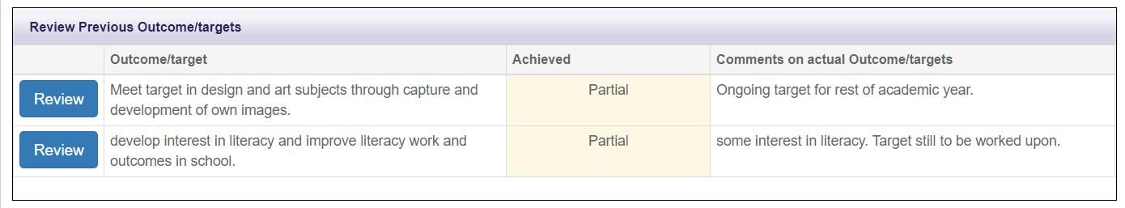
Setting new targets and requesting associated PP+ money
Targets can be set by pressing the “Create” button on the “Targets and PP+” page of the PEP.
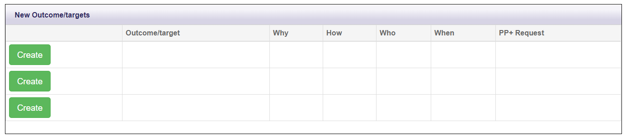
Having pressed Create a new window opens. This new window needs to be completed for each target. Remember to press “Save” when you have finished each target.
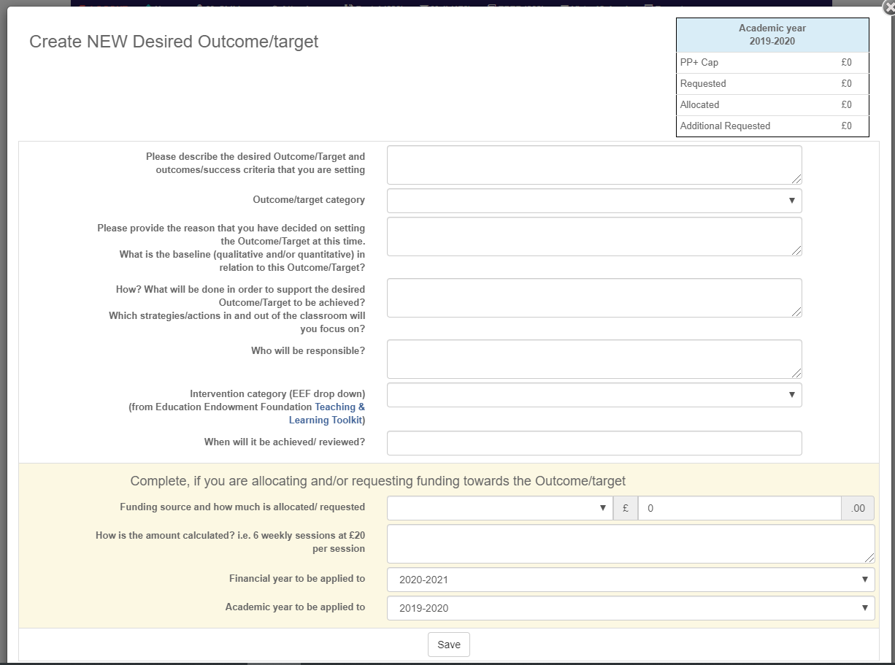
It is important to show clearly how the costs for each target is calculated. Two examples are below:
1:1 TA @ 20mins per day x 5 days per week x 12 weeks £5 x 5 days x 12 weeks = £300
1:1 TA @ 10mins per day x 3 days per week x 13 weeks; £2.50 x 3 days x 13 weeks = £97.50
Pupil Premium Plus for CLA from other Local Authorities
Different policies towards Pupil Premium Plus will be implemented by different LAs
Derby schools who have CLA from other Local Authorities on their roll must contact the headteacher of the relevant Virtual School to request their Pupil Premium Plus policy, as nationally, all VSHs are responsible for the allocation of Pupil Premium Plus for all school aged CLA from their authorities, even though the child is educated in a Derby school. The name and contact details of other VSHs can be requested from the Derby City Virtual School.

Adopted Children, Special Guardianship Order and Child Arrangement Order
In addition, through a separate process, children adopted from care or children who have previously been in care but now have a Special Guardianship Order or Child Arrangements Order (formally known as a Residence order) will be entitled to £2,690 passed directly to the school. However, this grant is outside the remit of this policy.
For further information on this please refer to: https://www.gov.uk/government/publications/pupil-premium-allocations-and-conditions-of-grant-2020-to-2021/pupil-premium-conditions-of-grant-2020-to-2021
BACS details required for Pupil Premium Plus funding to be paid over to you:
Please submit a letter addressed to Derby City Council, on School letter headed paper with your address, which contains the information stated below. The letter should request that bank details are set up / changed. Please return this by attaching it to the “Documents“ section of the pupil’s ePEP, or emailing it to elizabeth.williams@derby.gov.uk.
Note: failure to send the required information will prevent your ePEP from being processed and paid.

Bank Name
Bank Address
Account Name
Account Number
Sort Code

If applicable:
Company Registration Number
VAT Number

Signature

Name

Position

Date

Contact Details
E-mail for remittance advice
E-mail address general
Contact Details for the Virtual School
In the first instance all enquiries about Pupil Premium Plus should be directed to Elizabeth Williams – see below:

Section/Role | Name | Email Address | Tel No
Headteacher of the Virtual School | Graeme Ferguson | Graeme.ferguson@derby.gov.uk | 07812301044
Specialist Education Officer for CiC | Mandy Fogg | mandy.fogg@derby.gov.uk | 07345490671
Specialist Education Officer for CiC | Catherine Ward | Catherine.ward@derby.gov.uk | 01332 640346
Specialist Education Officer for CiC | Philip Harris | Philip.harris@derby.gov.uk | 07385686411
Specialist Education Officer for CiC | Susannah Beadle | Susannah.beadle@derby.gov.uk | 07748624716
Specialist Education Officer for CiC | Nina McNelis | Nina.mcnelis@derby.gov.uk | 07385419824
Specialist Education Officer for CiC | Genevieve McCaskill | Genevieve.mccaskil@derby.gov.uk | 07741091375
Specialist Education Officer for CiC | Carla Dewberry | Carla.dewberry@derby.gov.uk | 07469 368281
Project Support Administrator | Liz Williams | Elizabeth.williams@derby.gov.uk | 01332 640342
Project Support Administrator | Ruby Turkington | Ruby.turkington@derby.gov.uk | 01332 647840

