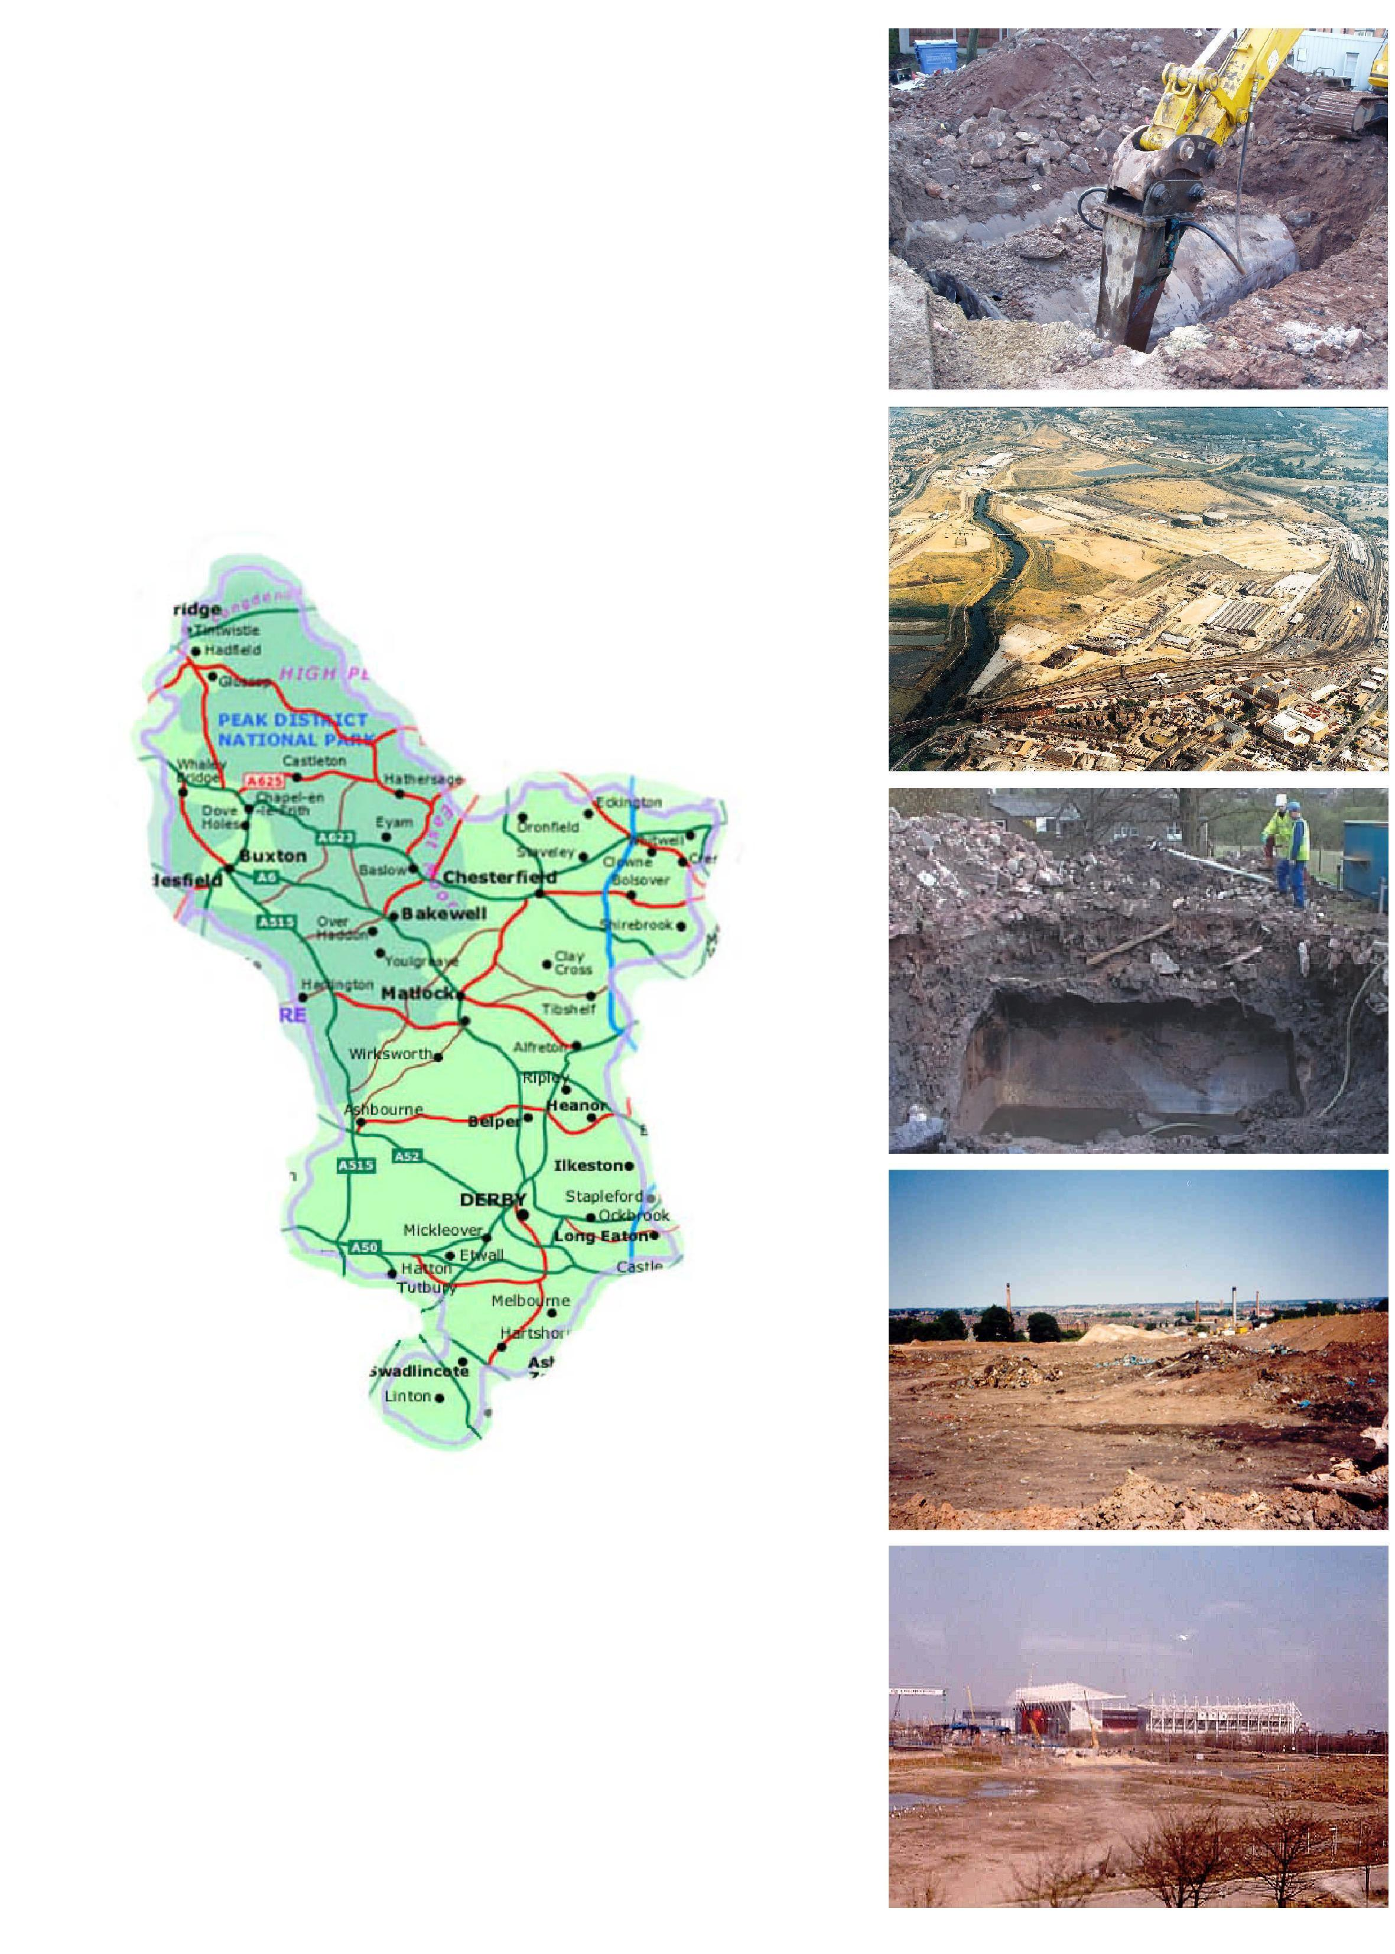
DEVELOPING LAND WITHIN DERBYSHIRE

A guide to submitting applications for
land that may be contaminated
Essential reading for landowners, consultants and applicants

Version 4 – March 2010

Produced by the Derbyshire Contaminated Land Sub-Group

1. Introduction

For many years, government has recognised the need to reclaim and develop areas of land, which is a legacy of our industrial past. In 2000, the Government set a target that 60% of new housing should be built on previously developed land, with the aim of reducing the pressures on the development of green belt land.

Due to this Government initiative, local authorities in Derbyshire are dealing with an increasing number of planning applications for developments on previously used land. Many of these sites are affected by the presence of contamination due to previous industrial uses. Examples of industry types that are common throughout Derbyshire include tanneries, coal mining, former town gas sites, foundries, quarries and cottage industries such as textiles.

1.1 What is this document for

The purpose of this guidance is to make developers aware of what information the Council will require in order to assess an application for planning permission on land which may be affected by the presence of contamination. This guide is not an exhaustive list of requirements, although it includes minimum requirements for investigations, reports etc, and developers are encouraged to speak with the contaminated land officer in the Council’s environment and regulatory services department.

2. The Council’s approach

Under both environmental and planning legislation, landowners and developers have the responsibility for establishing the extent of any potentially harmful contaminants on their sites. All councils have a duty to ensure that landowners and developers carry out the necessary site investigations and, where applicable, ensure that landowners and developers devise suitable remediation strategies so that any contamination is dealt with in a responsible and effective manner. It is the responsibility of the developer to ensure that the site is suitable for its proposed use.

2.1 Liaison with the Council

When a developer is proposing to develop on land that may potentially be contaminated, it is advisable to contact the Council’s contaminated land officer to discuss any land contamination issues prior to submitting a planning application. Advice will be given on the type of information that should be submitted with a planning application. Hopefully, this liaison should prevent any time delays or misunderstandings at a later stage in the development.

2.2 Definition of ‘suitable for use’

Clean-up or remediation of contaminated sites must be carried out with due consideration to the risk posed by the site. UK policy is that sites should be remediated based on the suitable for use principle. This principle allows a decision to be made as to whether there are unacceptable risks to people or to specific parts of the wider environment, including property, from the actual or intended use of the site. Each case will be assessed on a site-specific basis. This risk assessment can then be used to determine the extent of the remedial works needed.

Within the suitable for use approach, the option is always open to the person responsible for a site to do more than would be enforced through regulatory action. Redevelopment of previously contaminated sites is encouraged since this lessens the need for development on greenfield or previously undeveloped land and improves the environment as a whole. Developers should not be put off remediation for fear that they will be required to do more work that is required under current legislation – clean-up to residential development standards would not be required is an industrial development was proposed.

In the event that a more sensitive end use would be required in the future, more stringent controls would be applied at the time of the application and further remedial works may be required. Therefore some developers may choose to carry out further work at the start of a project as this may prove the most cost-effective long-term solution for the site. However, this is a judgement that only the person responsible for the site can make.

3. The site investigation procedure

The site investigation procedure will identify potential contamination and possible areas that may require remedial works in order to make a site suitable for its proposed end use. The site investigation can be split into three phases. The phases may be submitted individually as separate reports, or as one combined report. A checklist has been included in the centre of this document for your information and use. Reference should be made to Contaminated Land Report 11 – Model Procedures for the Management of Land Contamination before carrying out any phase of the site investigation procedure.

3.1 Minimum requirements for Derby City Council

In keeping with the guidelines for site investigations in Contaminated Land Report 11, Derby City Council’s Environment and Regulatory Services department has set minimum requirements for site investigation scheme, including procedures and reports. Boxes 1 to 4 below give these requirements, which form the detail to the standard planning condition attached to the grant of outline planning permission for developments on land that is potentially affected by contamination. Please note that schemes that do not fulfil each relevant requirement i.e. as specified by the planning condition, without written dispensation from the Local Planning Authority will not be considered sufficient to allow discharge of the planning condition to which they apply.

Box 1

The scheme shall include all of the following measures, Phases I to III, unless the Local Planning Authority dispenses with any such requirement specifically and in writing:

i) Desk study/phase I

A desk study shall be carried out to identify and evaluate all potential sources of contamination and the impacts on land and/or controlled waters, relevant to the site. The desktop study shall establish a ‘conceptual site model’ and identify all plausible pollutant linkages. Furthermore, the assessment shall set objectives for intrusive site investigation works/quantitative risk assessment, or state if none required. Two full copies of the desktop study and a non-technical summary shall be submitted to the Local Planning Authority without delay upon completion.

PLEASE NOTE: Sitecheck reports and similar, such as Homecheck and Groundsure residential searches, do not satisfy the needs of Contaminated Land Report 11, model procedures for the management of land contamination for the production of a Phase 1 report. These are conveyancing reports for purchasing property and are not designed for use as part of the process of developing a site under the needs of Planning Policy Statement 23. The use of such reports will be dismissed by the Local Planning Authority as being unsuitable and will not allow discharge of land contamination conditions without further works being undertaken. If in you are in any doubt about the work needed or are unsure please ask the Local Planning Authority what is needed before purchasing your report.

- Intrusive Site Investigation/phase II

If identified as being required following the completion of the desk study, an intrusive site investigation shall be carried out to fully and effectively characterise the nature and extent of any land contamination and/or pollution of controlled waters. It shall specifically include a risk assessment that adopts the contaminant-pathway-receptor principle, in order that any potential risks are adequately assessed taking into account the site’s existing status and proposed new use. Where samples are taken they shall be analysed in a laboratory that is accredited under The Environment Agency’s Monitoring Certification Scheme for all parameters requested where this is available. Two full copies of the site investigation and findings shall be forwarded to the Local Planning Authority without delay upon completion.

- Remediation method statement/phase III

A written method statement detailing the remediation requirements for land contamination and/or pollution of controlled waters affecting the site shall be submitted and approved by the Local Planning Authority, and all requirements shall be implemented and completed to the satisfaction of the Local Planning Authority. No deviation shall be made from this scheme without the express written agreement of the Local Planning Authority.

If during the development any contamination is identified that has not been considered in the remediation method statement, then additional remediation proposals for this material shall be submitted to the Local Planning Authority for written approval. Any approved proposals shall thereafter form part of the remediation method statement.

Should soils require removal off site, as part of the on site remediation, appropriate methods of disposal must be undertaken and considered in the Remediation Method Statement. From 16th July 2005 Waste Acceptance Criteria (WAC) applies to all hazardous waste going to landfill. Where samples are taken for WAC analysis they shall be analysed in a lab that is accredited under The Environment Agency’s Monitoring Certification Scheme chemical testing of soils scheme. Results of the WAC testing shall be forwarded into the Local Planning Authority.

Box 2

Prior to occupation of the development, or parts thereof, an independent verification report must be submitted demonstrating that the works have been carried out satisfactorily and remediation targets have been achieved, pursuant to Box 1 parts ii) and iii) above only. This report shall be produced by a suitably qualified and accredited independent body independent of the developer.

The report shall provide verification that the remediation works have been carried out in accordance with the approved method statement(s). Post remediation sampling and monitoring results shall be included in the report to demonstrate that the required remediation has been fully met.

Box 3

In the event that it is proposed to import soil onto site in connection with the development, the proposed soil should be verified at source to establish suitability as clean cover. However, the soil must be tested for contamination in situ, after it has been imported and analysed in a laboratory that is accredited under The Environment Agency’s Monitoring Certification Scheme Chemical testing of Soil Scheme, for all parameters requested, where this is available under The Environment Agency’s Monitoring Certification Scheme, the results of which shall be submitted to the Local Planning Authority for consideration. As a minimum, the following determinands and parameters should be tested:
arsenic, boron, cadmium, chromium III, chromium Hex VI, copper, lead, mercury, nickel, selenium, zinc, cyanide, phenol, sulphate, sulphide, pH, speciated Polycyclic Aromatic Hydrocarbons and carbon-banded Total Petroleum Hydrocarbons.

Please note that vendor certificates of the physical and nutrient properties of the matrix are not accepted in place of actual in situ sampling of the soil for the appropriate physio-chemical properties.

Box 4

Monitoring at the site for the presence of ground or landfill gas, as appropriate and a subsequent risk assessment must be carried out in accordance with a scheme to be agreed with the Local Planning Authority. All gas monitoring must comply with best practice as described in Construction Industry Research and Information Association C665, Assessing risks posed by hazardous gases to buildings. The results of the monitoring shall be submitted to the Local Planning Authority as soon as they are available.

If the presence of ground/landfill gas is confirmed, or there is evidence that migration of ground/landfill gas is likely to occur, development shall not commence until satisfactory remedial measures have been taken to control and manage the gas and to monitor the effectiveness of these measures. All such measures shall be agreed in writing by the Local Planning Authority before development.

- Phase I Reports and Desktop Study  submit for approval prior to development works | Included  Please tick
- Purpose and aims of study
- Site location and layout plans, appropriately scaled and annotated
- Appraisal of site history
- Appraisal of site walkover survey
- Assessment of environmental setting, to include:
- Geology, hydrogeology, hydrology
- Information on coal workings & other mining or quarrying activity, if appropriate
- Information from Environment Agency on abstractions, pollution incidents, water quality classification, landfill sites within 250m etc
- Assessment of current/proposed site use and surrounding land uses
- Review of any previous site contamination studies, desk based or intrusive or remediation works
- Preliminary risk assessment, based on proposed development, to include:
- Appraisal of potential and actual contaminant sources, pathways, and receptors, pollutant linkages
- Conceptual site model, diagrammatic and written
- Recommendations for intrusive contamination investigation, if necessary to include:
- Identification of target areas for more detailed investigation
- Rationale behind design of detailed investigation
- Phase II Reports - Detailed Investigation Reports  submit for approval prior to development works | Included  Please tick
- Review of any previous site investigation contamination studies, desk-based or intrusive, or remediation works
- Site investigation methodology, to include:
- justification of exploration sampling and analytical strategies
- Plan showing exploration locations, on site structures, above/below ground storage tanks etc, and to be appropriately scaled and annotated
- Borehole/trial pit logs locations
- Results and findings of site investigation, to include:
- Ground conditions - soil, gas and water regimes, including made ground
- Discussion of soil/gas/surface water contamination - visual, olfactory, analytical and monitoring data
- Conceptual site model, diagrammatic and written, including any changes from Phase I
- Risk assessment based on contaminant source-pathway-receptor model, to assess the consequences and likelihood of occurrence.
- Details of the site specific risk assessment model used and the justification in its selection and use should be stated
- Recommendations for remediation should follow the "suitable for use" approach - based both on the current use, circumstances of the land and the proposed site end use.
- Recommendations for further investigation if necessary

- Phase III Reports - Remediation Statements  submit for approval prior to remediation works | Included  Please tick
- Objectives of the remediation works
- Details of the remedial works to be carried out, to include:
- Description of ground conditions, soil, gas, water
- Type, form and scale of contamination to be remediated
- Remediation methodology
- Site plans/drawings, appropriately scaled & annotated
- Phasing of works and approximate timescales
- Consents and licences ie discharge consents, waste management licence, asbestos waste material removal licence etc
- Site management measures to protect neighbours, environment & amenity during works
- Details of how the works will be validated to ensure the remediation objectives have been met; to include:
- Sampling strategy
- Use of on-site observations, visual/olfactory evidence
- Chemical analysis and/or monitoring data
- Proposed clean-up standards i.e. contaminant concentration
- How any variations from approved remediation statement will be dealt with
- Whether validation will be phased
- Phase III - Validation Reports  submit for approval following remediation works | Included  Please tick
- Include information as detailed in 3. above
- Details of who carried out the work
- Details and justification of any changes from original remediation statement
- Substantiating data - should include where appropriate:
- Laboratory and in situ test results
- Monitoring results for groundwater and gases
- Summary data plots and tables relating to clean-up criteria
- Plans showing treatment areas and details of any differences from the original Remediation Statement
- Waste management documentation
- Confirmation that remediation objectives have been met

Recommended Guidance

- Assessing Risks Posed by Hazardous Ground Gases to Buildings. Construction Industry Research and Information Association C665, 2007

- BS10175: 2001 Investigation of Potentially Contaminated Sites, Code of Practice

- Classification and Selection of Remedial Methods, Construction Industry Research and Information Association, Volume 4, 1995 (SP104)

- Construction of New Buildings on Gas Contaminated Land, BRE, 1991

- Contaminated Land Exposure Assessment Model (CLEA), Department for the Environment, Food and Rural Affairs/Environment Agency Department/Environment Agency 2009 onwards

- Human Health Toxicological Assessment of Contaminants in Soil, Science Report Final SC050021/SR2 Department for the Environment, Food and Rural Affairs/Environment Agency, January 2009

- Updated Technical Background to the Contaminated Land Exposure Assessment Model, Science Report Final SC050021/SR3 Department for the Environment, Food and Rural Affairs/Environment Agency, January 2009

- Contaminated Land Report 11: Model Procedures for the Management of Land Contamination, Department for the Environment, Food and Rural Affairs/Environment Agency, 2004

- Department of the Environment, Industry Profiles, 1995

- Guidance for Safe Development of Housing on Land Affected by Contamination, Environment Agency/National House Building Council, Research and Development Publication 66

- Guidance on Evaluation of Development Proposals on Sites Where Methane and Carbon Dioxide are Present. National House Building Council & RSK Group plc, March 2007

- Methodology for the Derivation of Remedial Targets for Soil and Groundwater to Protect Water Resources, Research and Development Publication 20, Environment Agency 2001

- Planning Policy Statement 23, Planning and Pollution Control Office of the Deputy Prime Minister (2004) Her Majesty’s Stationery Office

- Protection of Workers and the General Public During the Development of Contaminated Land Her Majesty’s Stationery Office 1991

- Remedial Engineering for Closed Landfill Sites, Construction Industry Research and Information Association, C557, 2001

- Research and Development Publications: Toxicological Reports, Department for the Environment, Food and Rural Affairs/Environment Agency, 2009 onwards

- Secondary Model Procedures for the Development of Appropriate Soil Sampling Strategies for Land Contamination, Research and Development P5-066/TR, Environment Agency 2000

- Site Investigation and Risk Assessment, Construction Industry Research and Information Association, Special Publication, Volume 3, 1995, (SP103)

- Soil Guidelines Values (SGVs), Department for the Environment, Food and Rural Affairs/Environment Agency, 2009 onwards

Useful web sites

www.ambervalley.gov.uk | www.environment-agency.gov.uk
www.bolsover.gov.uk | http://www.communities.gov.uk/
www.chesterfieldbc.gov.uk | www.defra.gov.uk
www.derby.gov.uk | www.cieh.org
www.derbyshiredales.gov.uk | www.lga.gov.uk
www.erewash.gov.uk | www.ciria.org.uk
www.highpeak.gov.uk | www.bre.co.uk
www.ne-derbyshire.gov.uk | www.bsi-global.com
www.south-derbys.gov.uk | www.english-heritage.org.uk

Useful Contacts

 | Amber Valley Borough Council | Tel 01773 570222  Fax 01773 841407
 | Bolsover District Council | Tel 01246 242424  Fax 01246 242423
 | Chesterfield Borough Council | Tel 01246 345767  Fax 01246 345760
 | Derby City Council | Tel 01332 716332  Fax 01332 716330
 | Derbyshire Dales District Council | Tel 01629 761212  Fax 01629 761165
 | Erewash Borough Council | Tel 01159 072244  Fax 01159 316079
 | High Peak Borough Council | Tel 0845 129 77 77  Fax 01298 27639
 | North East Derbyshire District Council | Tel 01246 231111  Fax 01246 217447
 | South Derbyshire District Council | Tel 01283 221000  Fax 01283 595855
 | Derbyshire County Council | Tel 0845 6058 058  Fax 01629 585279
 | Environment Agency | Tel 0845 9333 111
 | DEFRA – Department for the Environment, Food and Rural Affairs | Tel 0845 933 55 77

Further detailed guidance on the information needs for preliminary risk assessment is given in CLR 11, Model Procedures for the Management of Land Contamination, pp.54-55.
Further guidance on preparation of site investigation reports for generic risk assessments is given in CLR 11, pp.71-72
Further guidance on preparation of remediation strategy reports is given in CLR 11, p.120
A full checklist of items to include (as applicable) in the verification report can be found in CLR 11, pp 144-147. Additional detailed guidance on verification procedures and reports is provided by the Environment Agency in their draft Verification for Remediation of Land Contamination.

