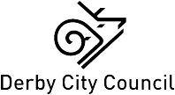  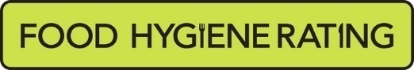  Food Hygiene Rating Scheme:  Appeal form | 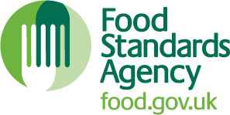

Notes for businesses:

- As the food business operator of the establishment you have a right to appeal the food hygiene rating given following your inspection if you do not agree that the rating reflects the hygiene standards and management controls found at the time of the inspection.
- You have 21 days (including weekends and bank holidays) from the date of receipt of the notification letter to lodge an appeal.
- Please use the form below and return it to the Lead Officer for Food from your local authority – contact details are provided with the written notification of your food hygiene rating.
- The Lead Officer for Food will review your rating and communicate the outcome of your appeal to you within 21 days.

Business details
Food business operator/proprietor

Business name

Business addresses

Business tel. number |  | Business email

Inspection details
Date of inspection |  |  |  |  | Food hygiene rating given
Date notified of rating

Appeal
I do not agree with the food hygiene rating given by the food safety officer because (please explain below under each of the three headings).

Compliance with food hygiene and safety procedures

Compliance with structural requirements

Confidence in management/control procedures

Signature
Name in capitals

Position |  | Date
Return this form to: The Food and Safety Team, Derby City Council, The Council House, Corporation Street, Derby, DE1 2FS or electronically to FoodandSafety.Duty@derby.gov.uk
The Food and Safety Team of Derby City is committed to protecting and respecting your privacy when you use our services.

How is your information used?

In performance of our public tasks use the information collected to enable us to contact you in relation to food hygiene and health and safety inspections, during the investigation of complaints about your businesses and to keep you informed on new guidance or legal requirements. In the case of an investigations or complaints, the information may be used to identify the source of illness, identify the cause of an accident or investigation breaches of businesses obligations in law.

Who will your information be shared with?

Your information may be shared within the Council, and with external agencies and other Government Departments. We do not share your information with anyone else unless we are required to do so by law or it is necessary to provide our services to you. We may share your information with the following:

Internal: Building Control, Environmental Protection, Licensing, Trading Standards Land Charges, Planning etc.
External: Derbyshire Fire and Rescue, Public Health England, Health and Safety Executive, HM Revenues and Customs, Police Quality Care Commission etc.

We will not sell or rent your information to third parties. We will not share your information with third parties for marketing purposes.

For further information about how your personal information will be used, please visit www.derby.gov.uk where you can see a full copy of our Privacy Notice. Alternatively you can request a hard copy from the Contact Support Team, Business Support, Derby City Council, Council House, Derby DE1 2FS. Email: contact.support@derby.gov.uk Tel: 01332 640825.

